HATE FOR our savior AND HIS FOLLOWERS MOUNTS HIGHER AND GREATER

September 18, 2023: A Carnival in Brazil mocks and scorns Jesus, as a man dressed in a Satan suit drags him and pokes at him with his pitchfork. The crowd rolls in laughter. News and video: “Brazil Worships Satan and Mocks God at 2023 Carnival” by Michael Adzato. The following 7 pictures below, from the video, are courtesy of my little Kodak camera… The action was fast, so some is blurred.


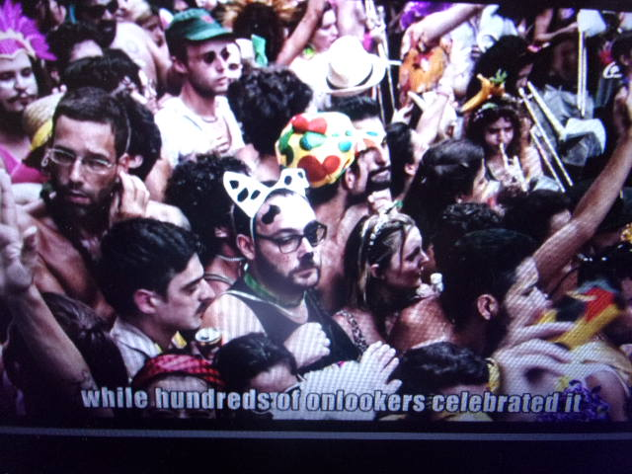





TWO DAYS LATER A DEVASTING STORM HIT THIS AREA WITH LOSS OF LIVES…


Philippians 2:5-11, ESV: “Have this mind among yourselves, which is yours in Christ Jesus, 6who, though he was in the form of God, did not count equality with God a thing to be grasped, 7but emptied himself, by taking the form of a servant, being born in the likeness of men. 8And being found in human form, he humbled himself by becoming obedient to the point of death, even death on a cross. 9Therefore God has highly exalted him and bestowed on him the name that is above every name, 10so that at the name of Jesus every knee should bow, in heaven and on earth and under the earth, 11and every tongue confess that Jesus Christ is Lord, to the glory of God the Father.”

Matthew 10:21-25: “Brother will deliver brother over to death, and the father his child, and children will rise against parents and have them put to death, 22and you will be hated by all for my name’s sake. But the one who endures to the end will be saved. 23When they persecute you in one town, flee to the next, for truly, I say to you, you will not have gone through all the towns of Israel before the Son of Man comes. 24 A disciple is not above his teacher, nor a servant above his master. 25It is enough for the disciple to be like his teacher, and the servant like his master. If they have called the master of the house Beelzebul, how much more will they malign those of his household.”

Matthew 24:8-10: “All these are the beginning of birth pains. 9Then they will deliver you over to be persecuted and killed, and you will be hated by all
nations because of My name. 10At that time many will fall away and will betray and hate one another,…”

Those once-Christians who deny Jesus now to protect themselves, will hate the ones who do not deny Him. They will turn them in to their death, proving their loyalty to the Beast (Revelation 13). This deep hatred is already global.

The U.S. is already labeling “Evangelical Christians” as potential terrorists by the FBI. This hatred is globally promoted by various religions, backed by Lucifer/Satan, the fallen angels, the Nephilim, and the returning Rephaim (giants). The hatred is backed by humans who are in the camp of Lucifer, not born again, haters of “God” in general. Their minds have been taken over by the demonic forces of the children of the fallen angels and human women, just like in Genesis 6. Yahuwah once again is being forced to Judge mankind, beginning with the “household of faith.”
Yahuwah is in judgment mode and separating His children from all others.

Revelation 19:5-16, ISR: “And a voice came from the throne, saying, `Praise our Elohim, all you His servants and those who fear Him, both small and great!’ 6And I heard as the voice of a great crowd, as the sound of many waters and as the sound of mighty thunders, saying, `Halleluyah, for יהוה Ěl Shaddai reigns! 7 Let us be glad and rejoice and give Him praise, for the marriage of the Lamb has come, and His wife prepared herself.’ 8And to her it was given to be dressed in fine linen, clean and bright, for the fine linen is the righteousness of the set-apart ones. 9And he said to me, `Write, Blessed are those who have been called to the marriage supper of the Lamb!’” …11 “And I saw the heaven opened, and there was a white horse. And He who sat on him was called Trustworthy and True, and in righteousness He judges and fights. 12And His eyes were as a flame of fire, and on His head were many crowns, having a Name that had been written, which no one had perceived except Himself – 13and having been dressed in a robe dipped in blood – and His Name is called: The Word of Yahuwah. 14And the armies in the heaven, dressed in fine linen, white and clean, followed Him on white horses. 15And out of His mouth goes a sharp sword, that with it He should smite the nations. And He shall shepherd them with a rod of iron. And He treads the winepress of the fierceness and wrath of Ěl Shaddai (God Almighty). 16And on His robe and on His thigh He has a name written: KING OF KINGS AND MASTER OF MASTERS.”

All these mockers will be forced to bow to Yahshua. As He returns, He comes with the wrath of His Father. His Father is now in building-wrath mode as He was “in the days of Noah.” (Luke 17:26-30) One of Yahuwah’s big angels will throw Lucifer into the pit, along with the other fallen ones. These who mock Him now will stand in horror, get down on their knees, and worship Him, or else the pitchfork of Yahuwah will jab them.

The hate, the mockery, the vilifying of the Savior, is increasing to the point where all who profess Him as Savior and Master, as Deity, the Son of the Living Yahuwah, Elohim (John 17) will face martyrdom. It’s all set up with guillotines all over the U.S. right now. Worldwide, it will be a crime to be a Christian or Messianic. And who is internationally behind this in the natural world right now? Babylonian Talmud-guarding rabbis, the Shabbti Tzvi-Jacob Frank Zionist-Illuminists, Jesuits, the Illuminati itself, Freemason hierarchy aligning with Lucifer.

The world now is under the laws of the Babylonian Talmud of rabbinic Judaism – clear to the International Court in the Hague – Netherlands. The Babylonian Talmud is the basis of law in the U.S., and the Noahide Laws that sentence all to beheading who do not follow that law. It became law in America in the early 1990s, as you can read about under the Mikvah of Present Reality #13.0 May 2008 “Beware of the Noahide Laws.” Under the Mikvah of Israel, there are about 21 articles, beginning with #52.0 over 2019, that tell about this in detail. The one to really read is the one that has pages of quotes from the Babylonian Talmud: “Quotes That Forever Dispel Damning Lies” #62.0.

Globalism is taking over and two things top the list of Lucifer and his fallen army of angels, Nephilim, and humans are 1) the destruction of all born-again believers in Yahushua/Yeshua/Jesus/Yesu/Isa … 2) the destruction of all with DNA traceable to Abraham, Isaac and Jacob, of the House of Israel/Ephraim/Joseph (ten northern tribes) and the House of Judah (the 3 southern tribes of Jacob). These 13 tribes can all be traced by DNA to where they settled after leaving the Land and migrating West. Most all settled in Western Europe, the U.K., and especially in America.

I recommend that you get Ya’ir Davidy’s book The Tribes. Each tribe has been located and proved. The Ireland DNA bank has samples of all 13 tribes and their locations. Ya’ir and his team included 1 rabbi, Abraham Fels, and several Messianic Israelis. I became friends with all the Messianic Israelis except I never got to meet Stephen Collins. Fine, fine people! I met by “accident” Rabbis Fells – oh what a story I could tell you about that! (smile) This is not speculation as to tribal identity – it’s real. Abba has proved that to me in several ways literally. However, you must remember that no matter what human DNA we have, all who are born again by faith in Messiah’s death and resurrection can join with Him and His Father to enter the Kingdom and be with Them forever, as Their children too.

The hate will not stop. It will keep on until the earth is about emptied of people, as Messiah said it would be, as many prophetic Scriptures describe. The U.S. is Bible-prophesied many times to be totally obliterated. That’s in the works now. America is doing all they can, NATO to provoke Russia to attack. Russia doesn’t want to, but to save their nation, they have to.

It is rather shocking that this horrible display of mockery is in Brazil, a Catholic country. Yet, the Pope has mocked Jesus/Yesu in Latin, and demeaned Him. Yet, to know Him personally, we know the truth. I have seen Him face to face in 2003 in Jerusalem – I’ve given that testimony many times. Also, He first came to me and called me out when I was not yet 5. It was so real that it became the foundation for the rest of my life. He has miraculously healed me many times of serious things. I know His purity, His Deity, His nature, His ways and His thinking, which is like His Father. We must know Him so deeply as a Person, that we cannot deny Him for any reason. Same with His Father.

So, the time of world martyrdom of Christians and Messianics is coming quickly. In the meantime, we must get stronger and stronger, more bold, more solid in faith, more ready to meet our Master!
In His love, Yedidah May 24, 2024

