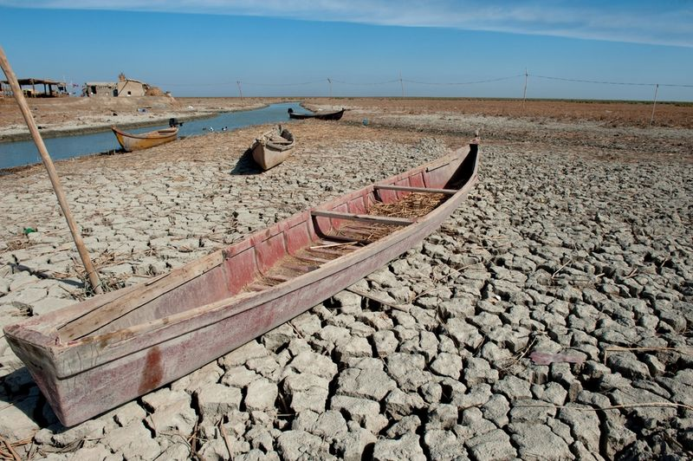

**REVELATION 16! The Euphrates River is Drying Up**

**Revelation 16:12-16**: “And the sixth angel poured out his bowl on the great river Euphrates, and its water was dried up, to prepare the way for the kings from the east. [13](http://biblehub.com/revelation/16-13.htm)And I saw, coming out of the mouth of the dragon and out of the mouth of the beast and out of the mouth of the false prophet, three unclean spirits like frogs. [14](http://biblehub.com/revelation/16-14.htm)For they are demonic spirits, performing signs, who go abroad to the kings of the whole world, to assemble them for battle on the great day of God the Almighty. [15](http://biblehub.com/revelation/16-15.htm)(“Behold, I am coming like a thief! Blessed is the one who stays awake, keeping his garments on, that he may not go about naked and be seen exposed! [16](http://biblehub.com/revelation/16-16.htm)And they assembled them at the place that in Hebrew is called Armageddon.”

On **December 29th**, the Pope will open the next portal of 5 - the portal in the Basilica of St. John Lateran. This door opening from December 24-January 6, 2025, is supposedly a good thing, for “salvation.” These 5 chosen places are laid out by location forming the “Sigil of Lucifer,” relate to **Revelation 16:12-13**? These three unclean spirits are seen as being like frogs. The word “Lateran” means “frogs.” It was made into a church by Constantine. St. John Lateran is known to be the first official Christian church.

Is there a connection to now? The River Euphrates is now basically dried up. The kings of the East are China, Russia, Iran, North Korea. Their military has been provoked by the U.S. and NATO for at least 3 years and are now prepared to bring about the amassing of the “Armageddon” army.

Is this a coincidence that this Basilica, the first official Christian church, “Basilica,” is going to have a “portal” opened on Dec. 29, 2024? What are these “portals?” Pure Luciferic; we know that.

Please read the amazing information in: “**The Gates of Hell Are Fully Opening – Abba’s Prophetic Warning**” #209.0 under the mikvah of The Heart of Elohim. Posted December 24, 2024.

Be sure you read: “**A Prophetic Look At the Deadly Earthquake in Turkey Near the Headwaters of the Euphrates River**” #307 under the mikvah of Present Reality. The Euphrates has always been a powerful River. Here is a map of it, from the headwaters in Turkey down below Baghdad, Iraq.

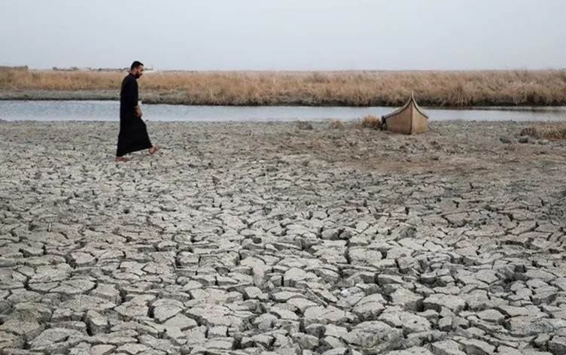

Right now, Turkey controls the flow of water from their Ataturk Dam

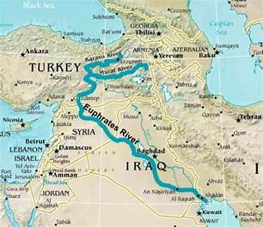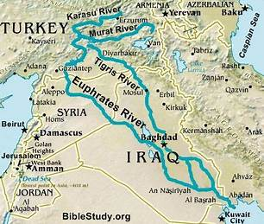

The great earthquake in Turkey damaged part of the Ataturk Dam also…

Refer to #307.0 Mikvah of Present Reality for the article: “A Prophetic Look At the Deadly Earthquake in Turkey Near the Headwaters of the Euphrates. It contains pictures also. Several factors have caused the drying up of the Euphrates and the Tigris in the last few years. But, whatever the cause – it is still began at the opening of the **Revelation 16** narrative about what has and is happening right now to set things up for armies in the millions to cross over, to set up weapons, and proceed to bring about a devastating element to WWIII. In reading **Revelation 16**, you may have questions, like “what happens to release the 3 frog-like things that ends up with Armageddon, or Har Megiddo in Hebrew. Folks, the spiritual opening of portals by one who is demonic himself, could be the Luciferian instigator of the opening of what is under the Euphrates from the pit.

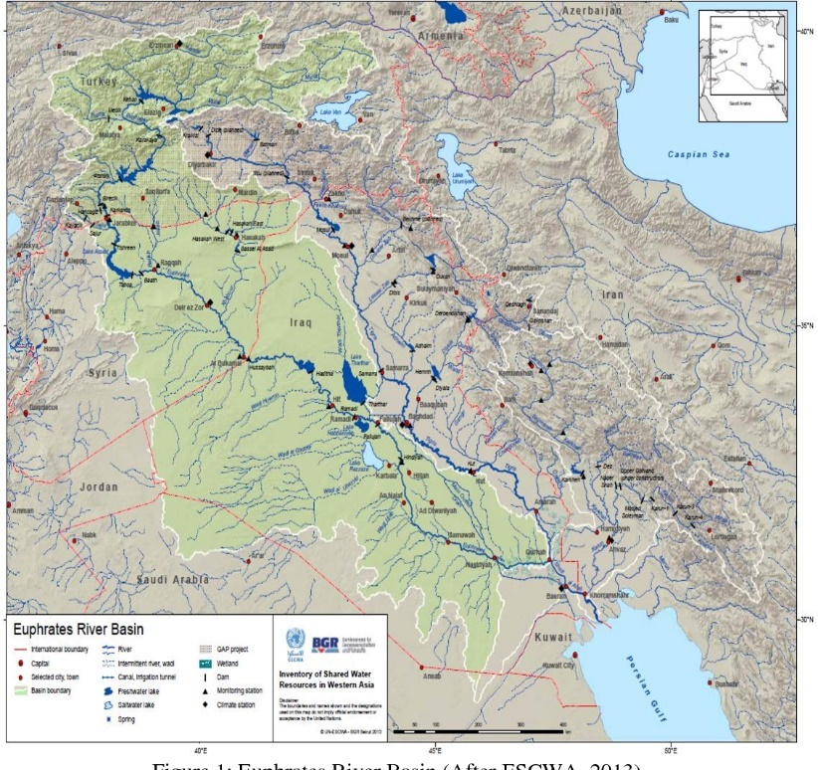Euphrates: Many Tributaries 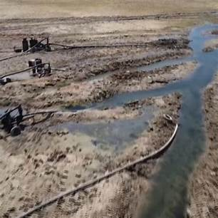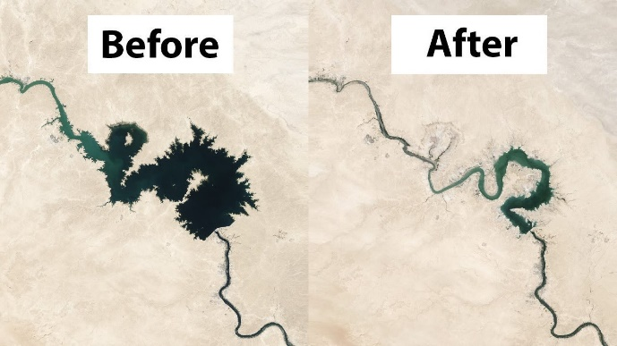

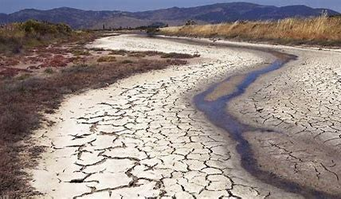

You get the idea…And after the great earthquake – it’s damaged more.

I may just put the information I’ve gathered: “**REVELATION 16: THE LATERAN BASILICA AND THE FOUR ELEMENTS OF SCIENCE”** - Research Notes 6/15/ 2013 into the latter part of this article.

Finally: This is amazing and is baffling scientists. Since the severe results of the Euphrates dying up this is appearing more and more, **unusual pits are exposing golden mountains underneath.**

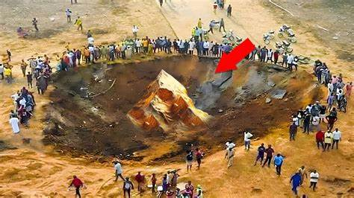

Why is this a shocker? Well, for one thing no one expects to find mountains underneath the earth. But, if you’ve read the very important article posted yesterday – “The Gates of Hell Are Fully Opening – Abba’s Prophetic Warning” #209.0 Mikvah of the Heart of Elohim, you know about the “golden glow of Notre Dame” in Paris is connected to the “Golden Age” of Lucifer’s reign that is prophesied to come. It is all about the setting of Lucifer’s final plans into motion, which brings on the “Bestial” anti-messiah. Now because of the **Revelation 16** prophetic word coming to pass to release the 3 under the path of the Euphrates, for the army of Har Megiddo/Armageddon to take place, we can expect a lot of things to surface that fit the scenario.

Talk it all over with Abba! What do you need to do to prepare in every way – physically, mentally, and most important spiritually? I spent about 2 hours yesterday trying to find the article on this that I wrote in 2022. I could not find it. So, I wrote this one and got similar pictures and maps as I had in 2022. This is important, I suppose an update since what is happening with the Pope’s portal openings include the ancient Lateran Basilica, now the Pope’s personal cathedral.

I was in St. Peter’s Basilica, then the Lateran Basilica, around 2014. While both are beautiful and magnificent, there is a pall within them, manifesting through the statues and other symbols of paganism. It was in the Lateran Basilica that I had a very real experience. My son and daughter-in-law were in another part of the Basilica when this happened. I went to view a display which included a statue of the “Virgin Mary” in a head-bowed, praying position. Under the Spirit of Yahuwah, I addressed the spirit in the statue and proclaimed it’s end at the return of Yahushua.

Immediately, the statue came to life, and “Mary” lifted her head towards me to listen to what I had to say. It was shocking, but I knew I was not dealing with just a man-made statue alone, but one inhabited by a fallen entity. I later told my son and daughter-in-law. We were there doing intercession for Yahuwah.

Shalom, Yedidah – December 25, 2024