Daniel 3! MAY THE FOURTH
BE WITH YOU!
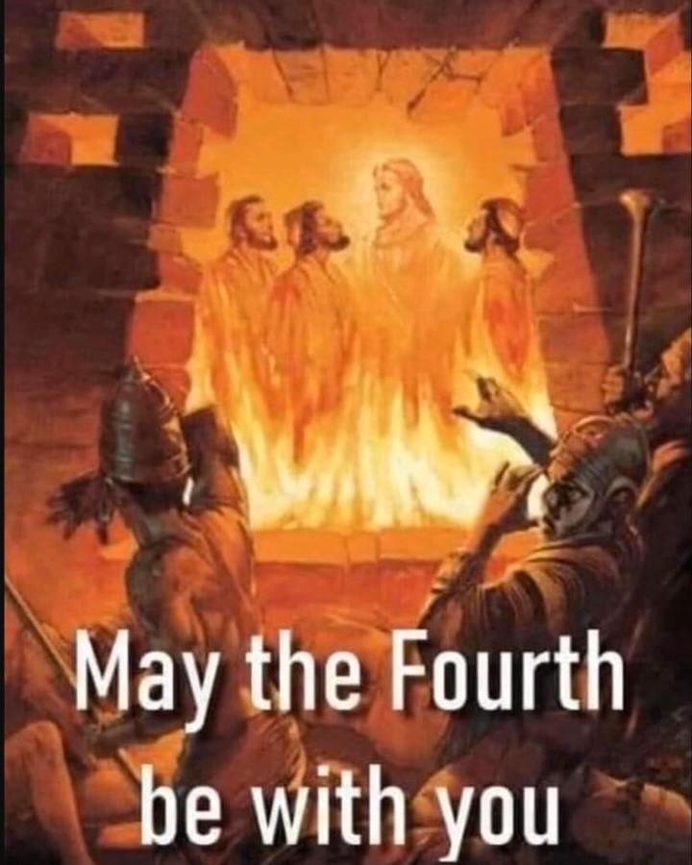
In famous sci-movies we’ve heard the expression “may the force be with you.” The “force” relating to supernatural powers of darkness – like the fallen angels, the hybrids of Genesis 6 born of fallen angels and human women, or “Nephilim.” The disembodied ones are known as “demons.” They must have a body to live through, so they find an entrance in human minds and walk right in and take over. The force speaks of the supernatural world of Lucifer.
However, in this poster-picture above, referencing the story in Daniel 3, it shows the three young friends of Daniel in the fiery furnace, and the fourth One who joins them – Yahushua Messiah. Yahushua/Yeshua/Jesus says to us: “I will never leave you or forsake you.” Those who are truly born again by faith in Him for eternal life are never alone, no matter what we go through. Those three came out of that furnace without even smelling like smoke, for Yahushua shielded them. May the “fourth” man never have to leave us due to our apathy towards Him!
The target of the fallen ones always, headed by Lucifer/Satan, is to kill all the descendants of Abraham, Isaac, and Jacob, the northern 10 tribes of the House of Ephraim/Israel and the 3 tribes of the House of Judah. This is why Christian nations are so targeted now for annihilation. The Beast cannot come to power with people on earth who know how to pray against him, against Lucifer, against the fallen angels, again the Nephilim. Many of the Nephilim are taking the bodies of former giants, “Rephaim,” who roamed earth. Many have been in statis for thousands of years and are being revived now. In Isaiah 13:2-3, Septuagint/Greek version of Tenach, Yahuwah says that He will use the “giants” to judge earth’s people.
Few, very few, pastors and Bible teachers, church leaders, “prophets” or “apostles” have a clue as to the reality of this passage of Scripture nor of Daniel 6, with Daniel in the lion’s den. They have no idea how it relates to today in 2024 and on. It speaks of the type of testing we will go through, extreme testing, to prove our faith in our Savior and our Heavenly Father.
Daniel 3 is an admonition to those on earth now professing to be “Christian. This type of extreme is soon to be the norm for the true children of Yahuwah and Yahushua, Father and Son.
The millions of martyrs for their faith in Yahushua, beginning with Stephen in Acts 7, are examples for us today. Hundreds of thousands are being martyred right now for not bowing to the world system, for being Christian, believers in Jesus, or Yeshua, whatever name of the Savior in Matthew, Mark, Luke and John. The Jewish Babylonian Talmud is International Law now. In it, Yahushua/Jesus is hated with satanic hate, brutal hate, all-consuming hate. It states that He was the son of Miriam and a Roman soldier – a “bastard.”
The Babylonian Talmud is the main religious book of Orthodox Jews, Hasidic Jews also. It came out of the time of the Babylonian captivity. The Pharisees adopted it, and in the first century it became the main book of their faith.
In the Talmud it speaks of what is known now as “Noahide Laws,” 7 laws that condemn monotheism by religious definition.
One of those 7 laws was used by the High Priest to send Yahushua Messiah to the Roman Governor Pilate for execution. The hate of the world’s people against “Jesus” as a primary name from Greco-Roman culture, is intense and bitter. In Matthew 10, Messiah said that all people everywhere would hate Him and hate those who love Him. It will be active International Law more and more that to believe in Yahushua (His Hebrew Name, meaning “Yahuwah is salvation”) or Jesus, or Yeshua, will bring the death penalty by beheading. We know that all over the U.S. FEMA camps are established with guillotines for that purpose. Yes, the Babylonian Talmud is American law and international law. It supports pedophilia, abortion, prostitution, and great hate against believers in the Savior, Yahushua.
The three Hebrews young men, friends of Daniel, would not bow to the statue of Nebuchadnezzar and worship him as a god. It was law that they had to bow to the statue. In Revelation 13, the bestial world ruler will demand worship, and all who will not worship his “image,” bow to his image, a statue or hologram, or whatever, will be killed. This is also international law, joined to the Talmud.
Please refer to: “Beware of the Noahide Laws,” Mikvah of Present Reality.
The U.S. and the world is turning quickly now to be a hater of the Savior, a hater of the Bible, a hater of the Creators … and a hater of those who are born again through faith in Them. Evangelical Christians are labeled as potential terrorists on the FBI list of dangerous groups.
Fiery furnace of lion’s den? Today the planned and written means of execution will be beheading by guillotine, or sword. All over the U.S. hidden under the Capital Building, hidden in FEMA camps, hidden elsewhere, are tens of thousands of guillotines. The holocaust of Christians and Messianic believers is near. Yet, the deceiving doctrines of the get-rich quick deceiving “prophets” and preachers say “nothing bad will happen to us,” - “we get raptured before the tribulation starts,” - “we have Psalm 91, “Jesus isn’t coming back until the whole world is saved and the churches flooded with believers.” Then there are the “remnant” preachers who think all good Christians will be a remaining remnant on the earth. They believe all live eternally in the throne room. They think all are the “bride.” They have no clue as to what the Bible says to counter those false beliefs! But, then, few teach on the coming of Messiah anymore.
However, the whole of Scripture does not teach that at all – but the opposite. When Messiah returns, He asks if anyone will be left alive, and if anyone left alive has faith. The earth will be emptied of human beings, of animals, birds, fish – anything that mirrors the Creators of all – Yahuwah, our Father, Yahushua, the Son.
The lollypop, cotton-candy doctrines of the false prophets abound. The denying of the Deity of the Savior is abounding. The denial of the Word, the Bible, as the Word of Yahuwah is abounding. The denial of the sinlessness of the Savior is abounding. False doctrines of “nothing’s going to happen to us,” “we’ll never have to suffer,” negates massive portions of the words of Messiah, the words of the apostles, the words of the prophets – from the whole of the Bible. But then Bible illiteracy is in the 90% range for western Christians – so they go by what sounds good to their “itching ears” – what soothes, what requires no responsibility on their part, what gives eternal life without the required “death to self.”
Here I is what Yahuwah gave my son, Derek, Shabbat morning May 18, 2024, to share with the congregation:
Derek’s prophetic word, Shabbat May 18, 2024, given at the Prayer Center: “Only one thing stands between me and the resurrection day – self! Death to self! Death to self must occur on our cross – Sha’ul said: `I die daily.’ Our dying words must be: `It is finished.’” Finished with my agenda, my pride, my religion, my idols, my philosophes, my compromise, my ideologies, my unforgiveness, my crookedness, my ways, my thinking my sin, my worldliness, my flesh, and all that keeps me tied to self. For Messiah on that cross, death was not the destination but a layover until He arrived back home, and when He arrived back home, He sent the Spirit to help us die in the same manner, because our end is not death, but life.
I die daily that I might live eternally. This is the finished work of the cross. Let go and embrace it!”
Messiah and the apostles warned a lot about these false prophets. Wow, Jeremiah warned a lot about these false prophets. Yet, for those who do not even read the Bible, let alone allow the Spirit of Yahuwah to teach it to their spirit, they do not know what is a lie, what is deception, or what is truth.
The Spirit of Yahuwah within us, as He once was in the “Holy of Holies” in the Temple is available to us. With His entrance to dwell in us, in our re-born Temple, He brings 9 gifts. (I Corinthians 12:1-11) The main one we need on a continual basis is the gift of the “discerning of spirits.” He wants to let us know what spirit is speaking to us – His Spirit, a human carnal spirit, or demonic spirits. It takes wisdom to discern, and the “gift of wisdom” is also a must for us.
To save their head, literally, so-called “believers” will deny Jesus right and left. But, He said, “if you deny Me before mankind, I will deny you before My Father who is in heaven.” (Matthew 10) Few now teach Matthew 24, Mark 13, Luke 21, II Thessalonians 2, II Peter 3, the book of Revelation, and massive portions of prophetic scripture throughout the Bible, from Isaiah through Malachi.
Here I want to insert what Yahuwah gave to my son on the morning of Shabbat May 18, 2024, the day before the Festival of Shavu’ot/Pentecost. He read this before he blew the shofar to begin our meeting at the Prayer Center:
“Death to self. Sha’ul said “I die daily.” If we do not die to our own will and carnal desires for this life, short-term and long-term, and are not led by the Spirit of Yahuwah, we cannot enter the Kingdom of heaven. Only the contrite, the humble, the yielded, the servants of Yahuwah and His Son Yahushua/Yeshua/Jesus can enter the Kingdom, through a true new birth following repentance of sin. We begin a life of yieldedness, or submission to a new Master. We come out of the kingdom of darkness ruled by Satan/Lucifer and fallen entities, and into a life of submission and obedience to the One who died for us and rose again.”
Without death to our will in this life, we stagnate. We cannot continue on to eternal life. Either Yahuwah is who He is, Shaddai, the Almighty One, and El Yon, the Most High, and we obey Him, as our Father, as our Master, or we sink back and fall away back into the kingdom of darkness, where Nephilim wait to enter and take over.
Either we go forward to the Kingdom of Light, or backwards into the darkness of an eternal pit of hell. The judgment seat of Messiah is for those who are truly born of Yahuwah’s Spirit and continuing on to know Him as Father, and His Son, as Beloved returning Messiah. The judgment seat of Yahuwah is for those who either have never received Messiah as Savior or have gone backwards into the darkness again and denied their salvation. (Revelation 20)
Yes, many Scriptures tell us to guard our salvation diligently, for if we turn from our Savior to serve ourself, the enemy will take over, and He will have remove our name from the Book of Life. Many Scriptures warn about this.
To the apathetic, lethargic, religious carnal believers, Messiah gave examples of why He will have to say to many: “Depart from Me; I do not know you.” A few verses on that: Matthew 7:23-24, Matthew 25:1-12, and Luke 13.
Death to self-will, yieldedness to His will, brings you into the throne room of Elohim (Father and Son), and sits you in “heavenly places.” The more dead you are to your own will, the more obedient to His will, the freer you are, the more joy-filled, the more excited about the future, the less fearful, the more secure, the more at peace.
Here are prophetic words given by Pastor Benjamin Faircloth May 19, 2024 at his church in Georgia. These prophetic realities are for us to take in “like Spirit.”
“We are in the midst of judgment now in America.” … “God doesn’t want to judge, but mankind forces Him to have to do it.” It is like a rebellious naughty child who will not listen to their Father but continually provokes the Father’s anger by his disobedience and aggressive rebellion. Pastor said that in his time of prayer Yahuwah said to him, “you are in a nation of dead men walking.” “We have no idea how close to death we really are, each and every day.”
Pastor Faircloth: Abba gave this to pastor for the nation: “Your people are walking into a trap… Your adversaries wait for you as you poke and prod your enemies, testing their resolve and tempting them to attack. They will overwhelm you. Intentions are weak, and you have no resolve. You are dead men walking. I offered you life; you chose death. I offered you peace, you chose death. You are dead men walking. You are living on borrowed time. Soon you will be paid the wages of sin. Touch not the accursed thing. Let the dead bury the dead. Let not your garments of righteousness be stained by the blood of those headed to the slaughter. They refuse to believe you because they refuse to believe me. Cursed be those who neglect so great a salvation…Take it to the Lord in prayer. It is definitely a dark saying.”
Pastor Faircloth, prophetic words: “The people have no idea they are walking into a trap, walking into death. No, they listen to false prophets and will be bitter and filled with anger and hate when they learn the truth and they are unprepared. People are making plans for a happy future, and we’re at the precipice of death,” he said. “The church is silent – not telling people about hell. People think because they have a religion, they’re OK with God. He said we need to be warning people.”
Ezekiel 33:6: The true watchmen are sounding the alarm – PREPARE! ALIGN WITH YAHUWAH! PREPARE OTHERS AS ABBA LEADS!
Russia is called upon by Yahuwah as Nebuchadnezzar was called upon in 586 BCE. “Every day, we get closer to being terminated as a nation.”
Choose your destination! You have only two options! You may have to go through the fiery furnace or the den of lions, or martyrdom, but make up your mind not to look back or turn back when challenged by the fallen ones to join them. There are liars. They want you in the pit of hell with them. The martyrs have great rewards: Examples: Revelation 2, 6, 7, 14. Make up your mind to remain loyal them, and They will keep you in perfect peace.
HalleluYah! The Master Yahuwah reigns! The Master Yahushua reigns! May the Fourth be with you everywhere you go, day and night, never leaving your side!
In Their love, Yedidah, May 21, 2024

