**URGENT UPDATE! RED LINE CROSSED! RUSSIA PREPARES TO RETALIATE!**

**WHERE IS YOUR BOMB SHELTER?**

Dear Americans, we sit on a powder keg of nuclear destruction and the fuse has been lit! The Big Question is: “Where is your bomb shelter?” My shelter in the eternal realm is in the Presence of Yahuwah and Yahushua … I hope yours is too.

You can read the article “Where’s Your Bomb Shelter? Who Warned You to Flee?”

Under the Mikvah of Present reality #259.0 from February 20, 2022.

You can also read “The Framing of Russia to Advance the Plans of Globalists,” #260.0 under the Mikvah of Present Reality. You can read Henry Gruver’s vision of Russia’s attack on the U.S., which is 263.0 in the article “DeNazifying of Ukraine,” but you can also read in the Bible what happens when America provokes the world’s military superpower to the point where the President has to retaliate and end the provoking and attempted annihilation of his people.

One thing you must understand, President Vladimir Putin loves his people. He tried and tried to make peace from the very beginning. He pleaded to have peace talks. Entity Biden refused to have peace talks. As the U.S. and NATO continued to use Ukraine to provoke more and more, even attacking Russian civilians to their death, still Putin tried to make peace. He finally let Biden know he was laying down a “red line,” cross it and Russia will use nukes against the U.S.

The goal was always to totally destroy America so that the one world government could easily take over. Now we’re on the precipice of it happening and the U.S. news is lying as usual, also being silent with any truth. Yet, right now, the nation sits waiting for total annihilation, total destruction, spoken of by Biblical prophets since the time of Isaiah, and especially Jeremiah.

In 1992, while reading **Jeremiah 50-51**, Yahuwah spoke to me: “This is America.” Few believed it. Now all of Yahuwah’s watchmen say it: “America IS end-time Babylon.” It’s spoken of in the majority of Bible prophecy of our day. **Revelation 18** describes New York City in detail after it is hit by Russian nukes.

Now, to make this short and specific, I will share with you a few articles that are bluntly truthful. It is for real. Joe Biden has made sure that we get hit – and hit before he leaves office.

**Article I**: “Russia’s Leaders Are Already in Their Doomsday Bunkers in the Urals and in Siberia.” Steve Quayle Alert!

“EMERGENCY WWIII ANNOUNCEMENT: General Flynn Warns Biden's Bombing Of Russia Has Lit The Fuse That Will Trigger WWIII— The Former Head Of The Defense Intelligence Agency Calls For Biden's Immediate Removal Under The 25th Amendment.” Alex Jones youTube Nov. 19, 2024

Blessings to General Flynn – yes, this unprovoked bombing of Russia has lit THE fuse to trigger WWIII. Biden should be removed immediately.

**“WWIII Alert: Biden Regime Sending Anti-Personnel Landmines Banned In 150 Countries, To Ukraine, In Yet Another Escalation In U.S. Proxy War Against Russia”**

“General Flynn warns Biden’s Bombing of Russia has lit the fuse that will trigger WWIII. The former head of the Defense Intelligence Agency calls for Biden’s immediate removal under the 25th Amendment.”

First the Biden regime lifts the block on Ukraine using U.S. missiles to hit targets within Russia, **making America**[**a direct party to the conflict**](https://www.allnewspipeline.com/Prepare_For_TEOTWAWKI.php)**between Ukraine and Russia, and now**[**the U.S. is sending anti-personnel landmines**](https://news.sky.com/story/what-are-the-anti-personnel-landmines-the-us-is-sending-to-ukraine-and-why-are-they-banned-by-more-than-150-countries-13257091)**, which are banned in 150 countries, including the UK, to Ukraine**.

It is noteworthy that the U.S. and Russia have not signed on to said ban, but this is **yet another escalation by the U.S. in directly interfering in a war that holds no national security benefits to America.**

Interestingly, Ukraine is a signatory of the ban of the use of these anti-personnel lands, but is considering withdrawing from the Ottawa Treaty, also known as the 1997 Anti-Personnel Mine Ban Convention.

“[Col. MacGregor: `Ukraine will be totally DESTROYED with nothing left if Biden doesn't stop NOW! THE USA STARTED THIS WHOLE MURDEROUS ESCAPADE BY REFUSING PEACE TALKS BETWEEN RUSSIA AND THE UKRAINE!](https://www.youtube.com/watch?v=61p3GxCE4vg)’

**Article II**: “Russia Evacuates Political Class to Nuclear Bunkers in Ural Mountains” November 19, 2024, Hal Turner reporting.

As of 11:12 PM eastern Standard Time on 19 November 2024 here in the USA, reports are now coming in saying the Russian Federation has evacuated its political officials to nuclear bunkers in the Ural Mountains.

It was reported by me in coverage yesterday that Russian President Putin had boarded an aircraft in Moscow at about 3:30 AM Moscow Time Sunday-into-Monday, and was flown to the Ural Mountains.

That report also revealed that high ranking Russian military officers - and their wives - were in the process of boarding planes or already flying out to the Ural Mountains just an hour or two after President Putin.

**All this activity within Russia began as soon as word came out the US President Joseph Biden**, who occupies the Office of President of the United States by virtue of Election Ballot FRAUD in the 2020 election, granted permission to Ukraine to use American-supplied, long-range missiles, to strike deep interior Russia.

Since at least September, the Russian government, up to and including its President, Vladimir Putin, have made clear to the world that western long-range missiles require satellites to guide them to target.  Ukraine has no satellites. In order for those western-supplied missiles to be fired by Ukraine, those missiles must get active guidance to target by US/European/NATO satellites. That active-guidance makes the US, European Union and NATO active combatants against the Russian Federation.

Russia over the past three weeks has repeatedly and publicly warned that if such western missiles were used against Russia, the response would be "imminent and devastating to the West."

Last night, Ukraine fired US-supplied ATACMS missiles into Bryansk, Russia.

So the threshold seems to have been crossed and now, Russia seems to be readying itself to respond.  The fact that the Russian President, Russian military officers, and now the Political members of the State Duma and the Federation Council, the two houses of Russia's Parliament, have also been evacuated to nuclear bunkers, seems to indicate what Russia intends to do: Fire nuclear weapons.

A Classified CIA Report from about 1978, outlines the massive underground city beneath the Ural Mountains, the highest mountains in all of Russia. This city, believed to be over five square miles in size, and ALL underground, is Russia's "Doomsday Bunker." **The USA has no supplied shelters at all for our civilian population.”**

**Article III**: “[RUSSIA'S LEADERS ARE ALREADY IN THEIR DOOMSDAY BUNKERS IN THE URALS AND IN SIBERIA: MOUNT YAMANANTU WATCH VIDEO LINK!](http://www.stevequayle.com/index.php?s=33&d=2617)” This is taken from a Private Briefing by Steve Quayle a few days ago.

“Russian Leaders are already in their Doomsday Bunkers! President Putin and all high ranking officials are already in this secret nuclear Armageddon fortress. This is one of the most elaborate nuclear proof-underground cities in the world. It is multi-level and rumored to be 4 square miles. In the past 72 hours all Russian leaders are now out of Moscow with their families and located in Yamantau and other similar and very secret underground cities.  
 Russia has prepared for their government to continue on and have pre supplied shelter system in place for all their major cities. The USA has no supplied shelters at all for their civilian population.  
 Russia intends to preserve their civilian population and their country's recovery plans while the U.S has no such shelters. President Putin values Russia's population while the west and most Nato countries don't care about their civilian populations. World war 3 is eminent. Not one of the U.S or Nato bunker command centers were built to withstand 50 megaton bunker buster hypersonic nuclear warhead. VIEW THIS LINK ABOUT YAMANTAU UNDERGROUND CITY---><https://www.youtube.com/watch?v=_46bimKA4N0> Nov 20, 2024

Video: Mount Yamantau – singular mountain out in the middle of nowhere …

**ARTICLE IV**:

Russia Deploying "Portable" Nuclear Shelters for Citizens [Hal Turner](https://halturnerradioshow.com/index.php/component/spauthorarchive/articles/HalTurner?Itemid=101) [World](https://halturnerradioshow.com/index.php/news-selections/world-news) November 19, 2024

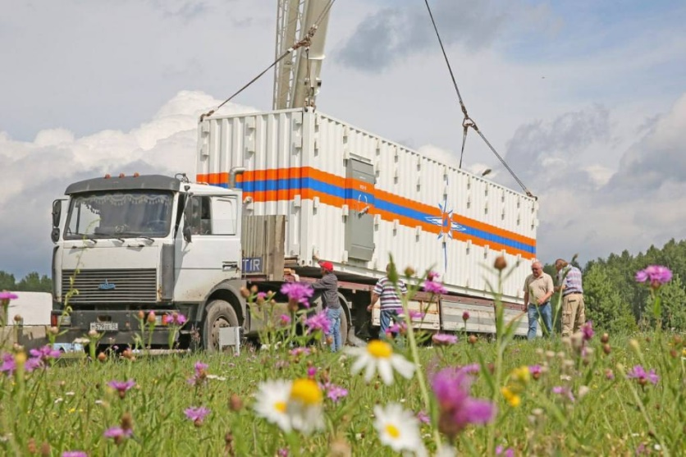

Russia has begun mass-production of, and full distribution of nuclear blast and radiation shelters for the public. The top photo, taken this past summer, shows what the shelters look like. The "KUB-M" package includes 2 modules - a technical module and a module for people, where 54 people can hide.

](https://halturnerradioshow.com/images/2024/11/19/Portable-Russian-Shelter-2.jpg)  
The mobile shelter provides protection from various threats, including natural disasters and man-made accidents. It can protect against light radiation from a nuclear explosion and radioactive contamination.

Once laid in place, the shelters are then surrounded by "Mafia Blocks" . . . cement blocks weighing approximately 3,000 pounds EACH, stacked one atop another and then over the roof.

While these appear to be shipping containers that one sees on an ocean-going ship, they are VERY MUCH meatier.  Look at the thickness of the walls and door in the photo below, taken before the paint is added:

](https://halturnerradioshow.com/images/2024/11/19/Portable-Russian-Shelter-4.jpg)

The sheer weight of each block helps keep them in-place, but the clearly visible steel racks also protect against movement.  Each block measures at least two feet thick, so being in one of these shelters is like being in something with cement walls two feet thick.  And it's all portable!  
 It was developed by the All-Russian Research Institute for Civil Defense and Emergencies (VNII GOChS), and production is underway in the city of Dzerzhinsk, Nizhny Novgorod Region.  
 The launch of serial production is supported at the state level, VNII GOChS reports. These portable nuclear shelters are the final stage of Russia's preparation for conflict with NATO.  The fact that these shelters are now being deployed, is a very ominous sign.

On MARCH 26, of the year 2015, the following news story about then-ongoing war shelters, appeared in Russia newspapers:

Russia Has Constructed Massive Underground Shelters In Anticipation Of Nuclear War. Russian television has reported that 5,000 new emergency nuclear bomb shelters were scheduled to have been completed in the city of Moscow alone by the end of 2012.

Most Americans don’t realize this, but the Russians have never stopped making preparations for nuclear war because they saw NATO expanding closer and closer to their country, after promising to "not move one inch eastward" at the time of re-unification of East and West Germany.

We promised Russia that if they allowed the re-unification of East and West Germany and pulled their three-hundred-thousand troops out of East Germany, NATO "will not move one inch eastward." Turns out, we lied.

One year later, in the year 2016, the London "Daily Mail" newspaper, ran a story confirming new Bomb Shelters; enough to house the ENTIRE population of Moscow:

"Bomb shelters in Moscow have been upgraded so that the city's entire population can be protected, according to Russian authorities" - 26 October 2016  
<https://www.dailymail.co.uk/news/article-3875092/Man-bunkers-Chilling-footage-shows-Russia-completed-nuclear-drill-40MILLION-people-Putin-builds-bomb-shelters-protect-Moscow-s-entire-population.html>

Meanwhile, the U.S. government has essentially done nothing to prepare our citizens for an attack. The assumption seems to be that a nuclear attack will probably never happen, and that if it does it will probably mean the end of our civilization anyway.

So if the present Russia-Ukraine conflict does go nuclear, as is now likely after Joe Biden gave permission for Ukraine to hit deep inside Russia with US missiles, then Russia survives and we in the USA do not.

Take that cold, hard, reality into account when you realize that after Biden gave Ukraine permission at 1:00 PM this past Sunday afternoon, Ukraine did, in fact, use such missiles to strike Russia last night.

Since American-supplied, and American satellite-guided missiles have now struck Russia, Russia has the right to strike us back. Here, inside the USA. They have shelters; we have none. They win, we lose.”

Prepare as you can. Turn off the lying public news. Abba’s watchmen have been warning for years. Mainly make sure you are at peace, knowing that Yahuwah is with you, never to forsake you. In His love, Yedidah, November 21, 2024