**THE RIDER ON THE WHITE HORSE**

**THE CROWNED CONQUEROR RIDES FORTH TO LOOSE…**

**A PROPHETIC EXHORTATION-CALL TO WATCH 2025**

**2025 NOTE:** This was posted under the Mikvah of Present Reality back in February 2017 after President Donald Trump was inaugurated for his first term. By March, I deleted this article from my list in 2017 thinking I’d said some wrong things. Yet Yahuwah has strongly let me know in the last two days that I must re-post it, so that I can build on the reality of it in 2025 following the inauguration of Present Trump’s second term, January 20, 2025.

**[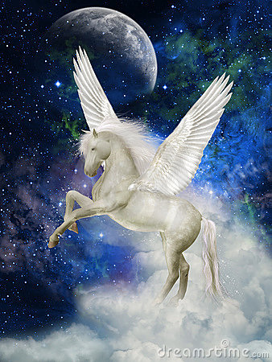](https://www.google.com/url?sa=i&rct=j&q=&esrc=s&source=images&cd=&cad=rja&uact=8&ved=0ahUKEwiVr6q4z5PSAhXL6CYKHaBDBPoQjRwIBw&url=https://www.pinterest.com/pin/412220172114385040/&psig=AFQjCNGKSDPE4xCiw2TH5IaYiO505YABNQ&ust=1487300132542176) [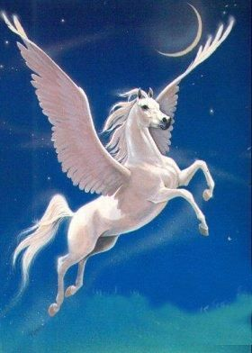](https://www.google.com/url?sa=i&rct=j&q=&esrc=s&source=images&cd=&cad=rja&uact=8&ved=0ahUKEwjmudjJz5PSAhXDKiYKHXCODsYQjRwIBw&url=https://www.pinterest.com/donnanach/birds/&psig=AFQjCNGKSDPE4xCiw2TH5IaYiO505YABNQ&ust=1487300132542176) [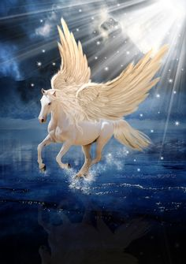](https://www.google.com/url?sa=i&rct=j&q=&esrc=s&source=images&cd=&cad=rja&uact=8&ved=0ahUKEwjC5vnVz5PSAhVI8CYKHbWSDAcQjRwIBw&url=https://www.pinterest.com/pin/431923420488887256/&psig=AFQjCNGKSDPE4xCiw2TH5IaYiO505YABNQ&ust=1487300132542176) [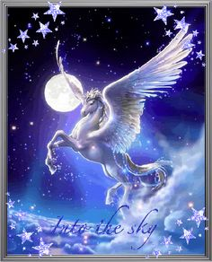](https://www.google.com/url?sa=i&rct=j&q=&esrc=s&source=images&cd=&cad=rja&uact=8&ved=0ahUKEwjElOj4z5PSAhUKKiYKHWKHAbMQjRwIBw&url=https://www.pinterest.com/pin/314970567661245736/&psig=AFQjCNGKSDPE4xCiw2TH5IaYiO505YABNQ&ust=1487300132542176)**

**The Greek god PEGASUS**

**[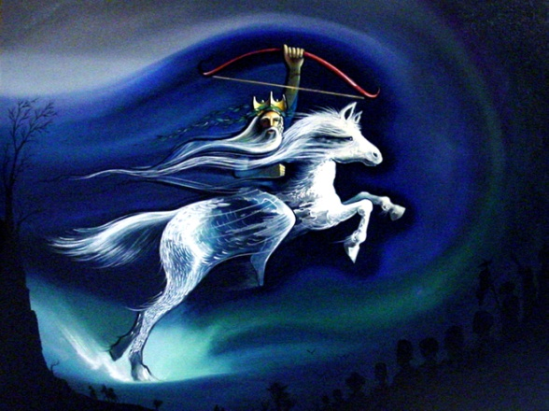](http://www.google.com/url?sa=i&rct=j&q=&esrc=s&source=images&cd=&cad=rja&uact=8&ved=0ahUKEwjetoPC0JPSAhVRgSYKHQtND_4QjRwIBw&url=http://www.peterolsenart.com/slide14.html&psig=AFQjCNEDTrtiLWcfCHrkK-6dx0Z__XYieQ&ust=1487300492628703) [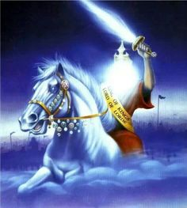](https://www.pinterest.com/pin/549439223261684451/)**

**Rider on the white horse – Revelation 6:1-3**

**[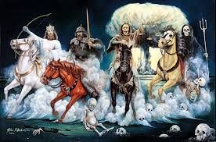](http://www.google.com/url?sa=i&rct=j&q=&esrc=s&source=images&cd=&cad=rja&uact=8&ved=0ahUKEwjV6ZvA0pPSAhUE7SYKHeUnBgYQjRwIBw&url=http://right.is/bible-prophecy/2015/09/are-the-four-horsemen-of-revelation-already-on-the-scene-you-may-be-shocked-by-the-answer-as-their-colors-have-a-much-deeper-meaning-35.html&psig=AFQjCNEDTrtiLWcfCHrkK-6dx0Z__XYieQ&ust=1487300492628703) [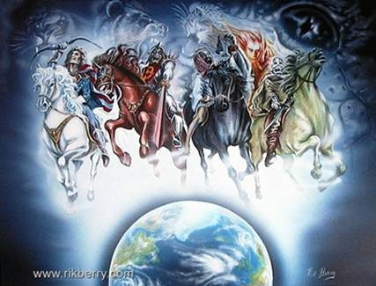](http://www.google.com/url?sa=i&rct=j&q=&esrc=s&source=images&cd=&cad=rja&uact=8&ved=0ahUKEwiYwfj005PSAhUGOCYKHXoACdMQjRwIBw&url=http://manualoflife.com/joeen/?p=2877&bvm=bv.147134024,d.eWE&psig=AFQjCNHFzRqDm8iJK32p0qAfvGGHVUZlkA&ust=1487301190691361)**

**The “four horsemen of the Apocalypse”**

**[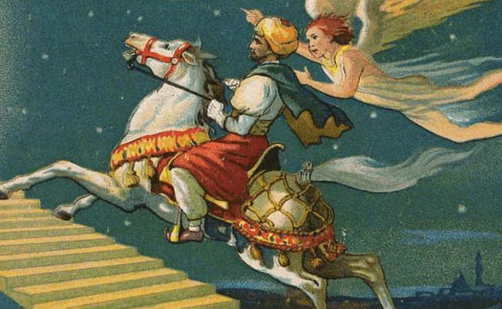](http://www.google.com/url?sa=i&rct=j&q=&esrc=s&source=images&cd=&cad=rja&uact=8&ved=0ahUKEwidn-zI1ZPSAhVJYyYKHZvmBdAQjRwIBw&url=http://pilgrimagestojerusalem3faiths.weebly.com/islam.html&bvm=bv.147134024,d.eWE&psig=AFQjCNEiDb2JtlbehkHKXlqlLtt8U0D2Tg&ust=1487301881702776) [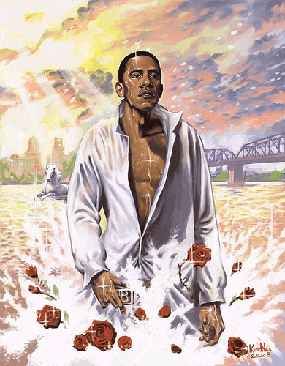](https://clearbluewatercomic.wordpress.com/2009/01/20/george-w-bush/obama/)**

**Mohammed riding his white The famous “White Horse” painting**

**on his famous “night journey” of Barack Obama with his white horse**

**[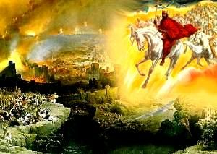](https://www.google.com/url?sa=i&rct=j&q=&esrc=s&source=images&cd=&cad=rja&uact=8&ved=0ahUKEwjz8fW31pPSAhWG7iYKHUZGCGIQjRwIBw&url=https://www.pinterest.com/pin/282741682826703995/&bvm=bv.147134024,d.eWE&psig=AFQjCNH8I_cWWGFvAA2Ntgqwk3-fYGZ1jg&ust=1487302117933065) [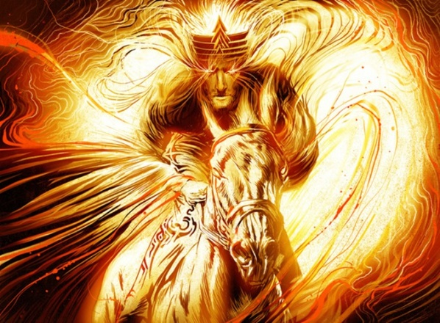](http://www.google.com/url?sa=i&rct=j&q=&esrc=s&source=images&cd=&cad=rja&uact=8&ved=0ahUKEwjr-9DK1pPSAhUBVCYKHeCgC1cQjRwIBw&url=http://www.dailystormer.com/an-overpopulated-world-rushing-toward-its-end/&bvm=bv.147134024,d.eWE&psig=AFQjCNH8I_cWWGFvAA2Ntgqwk3-fYGZ1jg&ust=1487302117933065)**

**Messiah returns on His white horse – Revelation 19:11-16**

**[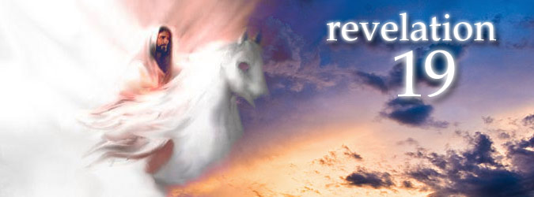](https://www.google.com/url?sa=i&rct=j&q=&esrc=s&source=images&cd=&cad=rja&uact=8&ved=0ahUKEwiC2-391pPSAhVLRCYKHfAlDHoQjRwIBw&url=https://uk.pinterest.com/explore/revelation-19/&bvm=bv.147134024,d.eWE&psig=AFQjCNH8I_cWWGFvAA2Ntgqwk3-fYGZ1jg&ust=1487302117933065)**

**Revelation 6:1-2**: “And I saw when the Lamb opened one of the seals and heard one of the living creatures saying, `Come and see.’ And I looked, and behold, I saw a white horse and he who sat on it holding a bow. And a crown was given to him and he went out overcoming and to overcome.”

**The symbolism of Pegasus**

Wikipecia: [Latin](https://en.wikipedia.org/wiki/Latin): *Pegasus, Pegasos* is one of the best known creatures in [Greek mythology](https://en.wikipedia.org/wiki/Greek_mythology). He is a winged divine stallion also known as a horse usually depicted as pure white in color. He was sired by [Poseidon](https://en.wikipedia.org/wiki/Poseidon), in his role as horse-god, and foaled by the [Gorgon](https://en.wikipedia.org/wiki/Gorgon) [Medusa](https://en.wikipedia.org/wiki/Medusa)… Greco-Roman poets write about his ascent to heaven after his birth and his obeisance to [Zeus](https://en.wikipedia.org/wiki/Zeus), king of the gods, who instructed him to bring lightning and thunder from Olympus**.** Zeus transformed him into the constellation [Pegasus](https://en.wikipedia.org/wiki/Pegasus_(constellation)) and placed him up in the sky. Hypotheses have been proposed regarding its relationship with the [Muses](https://en.wikipedia.org/wiki/Muses), the gods [Athena](https://en.wikipedia.org/wiki/Athena), [Poseidon](https://en.wikipedia.org/wiki/Poseidon), [Zeus](https://en.wikipedia.org/wiki/Zeus), [Apollo](https://en.wikipedia.org/wiki/Apollo), and the hero [Perseus](https://en.wikipedia.org/wiki/Perseus).”

The white horse is a symbol of the conquerors, kings, noblemen, and victorious military heroes who ride on his back. It’s interesting that the white horse is also associated with Apollo/Apollyon of **Revelation 9**.

Continuing from Wikipedia – “During [World War II](https://en.wikipedia.org/wiki/World_War_II), the silhouetted image of Bellerophon the warrior, mounted on the winged Pegasus, was adopted by the [United Kingdom](https://en.wikipedia.org/wiki/United_Kingdom)'s newly raised parachute troops in 1941 as their upper sleeve insignia. The image clearly symbolized a warrior arriving at a battle by air, the same tactics used by [paratroopers](https://en.wikipedia.org/wiki/Paratrooper).” (Picture on left)

[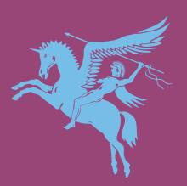](https://en.wikipedia.org/wiki/File:British_Airborne_Units.svg) [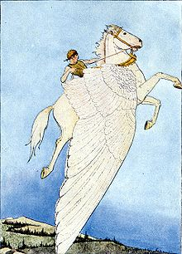](https://en.wikipedia.org/wiki/File:The-Winged-Horse.jpg)

British insignia Bellerophon riding Pegasus (1914 painting)

Pegasus was a winged, flying horse upon whom conquerors sat. Most of what we call Egyptian, Babylonian, Persian, Greek, or Roman mythology is simply stories of what the ancients actually saw in reality. The **Genesis 6** pre-flood Nephilim experimented with creating many hybrid mixtures of various species that became the gods of the ancient world, so a white horse with the ability to fly is not hard to fathom with the higher technology they had. **The rider on the white horse in Revelation 6 is riding a symbolic Pegasus.**

There are four prominent “religious” figures in today’s world, three of which have ridden, or are riding, symbolically white horses. Only one will ride a literal white horse. All of them are god-like figures. The white horse is a symbol of a conquering messiah, a ruler, a King.

As non-religious believers in Yahuwah and Yahushua, we look for only one who will ride a white horse--Yahushua Messiah, who comes with the wrath of Yahuwah to judge the earth, to raise the righteous ones from the dead, establish His Kingdom on earth, and rule and reign over it. But, mankind as a whole seeks a human-divine type leader to worship and follow. Today all religions are looking to receive their messiah--Islam being a major one, but also religious Jews look for a political conquer, Messiah ben David, to make Israel great again, and the New Age occultists are looking for their Maitreya, the “avatar of the Aquarian Age.” The neo-Druids, witches, warlocks, Satanists and Luciferics, neo-Nazis, and many political world rulers, too, are looking for the return of the sky gods to rule earth once again as they did before the Flood. Messianic fever has come to all cultures because the nations fear the coming of the Lion of Judah! (**Revelation 6:12-17**) Satan knows his time is short, so his fear and rage have intertwined against Yahuwah, Yahushua, and all those who worship Them.

In like manner, multi-millions of Americans in their starry-eyed thinking have put Donald Trump on the white horse as America’s messiah.

Some Bible teaching says that the rider of **Revelation 6:2-3** is the anti-messiah. But, he carries no weapon. Some have said he is represents the United Nations. But, because I have been tracking end-time prophecy for 54 years, I am watching carefully, only analyzing what I see as the Spirit of Yahuwah leads. Because we are in the time-zone when all prophecy is being fulfilled before the return of Yahuhua, I see that he may be a present-day figure that has come on the scene right now, one who is going forth as a messiah to his people to do good for his nation and the world, and yet in his attempts he falls prey to the plans of the evil rulers who want war, famine, economic collapse, and massive worldwide death in order to bring in a new world order? In other words, in going forth to do good he becomes the instrument of the evil ones to actually loose their destruction upon the human race.

Are we watching this figure riding now? All we can do is listen to Yahuwah’s Spirit deep within our re-born spirit and wait for clarification. We can’t really say “this is that” until “that” has passed by us and all the puzzle pieces fit together. But, let’s take a look at the possibilities of what we’re seeing.

My notes from an interview of Tom Horn by Derek Gilbert on Skywatch TV news on January 27, 2017: “Tom Horn quoted the *Zohar*, which contains the foundational teaching of Kabala. **He said that the Zohar relates that messiah will make himself known privately to the rabbis first, before revealing himself publically in the year 5773 (CE). That was 2012. Tom mentioned the timing as being Yom Teruah 5773 going into 2013 on the “Jewish calendar.” He said that at that time Donald Trump went to Israel to privately meet with Jewish leaders and chief rabbis, including a meeting with Benjamin Netanyahu. At that time, Donald Trump went on Israeli public TV in Israel to persuade voters to vote for Netanyahu. That was at the time when Netanyahu was up for re-election and Obama sent his team of backstabbers to Israel to sway the vote towards Netanyahu’s opponent.**

**Within days after Trump returned to New York, rabbis made a public statement that the messiah had revealed himself to them. 300 years ago, Daniel Nor Horowitz was studying Daniel 12 and his “time, times, and half a time.” He said: “Do not leave Jerusalem. The Messiah is here. He is about to reveal himself. He said he would make his appearance in October of 5777, going into 5778. 5777 is 2017. Jews believe he will be an anointed political leader as well as a warrior.** **The rabbis, Tom said, don’t say that Donald Trump is the messiah; they say he is a forerunner of the messiah**.

Right now, chief rabbis are calling on Putin and Trump to help them rebuild a “third temple,” even though they know **Zechariah 6:12-15--**that Messiah will build it.”

**PLEASE RE-READ: “The Trump Presidency Seen as God Electing a Modern King David to Kill America’s Goliaths Amidst Spiritual Decay and Yahuwah’s Pending Judgment “/January 24, 2017**

On the Bill O'Reilly News Program on the Fox News Network on 1/25/2017, Mr. O'Reilly made the comment paraphrased here "President Trump was like a tornado in his first 4 days in office, accomplishing more in 4 days than Barack Obama had in 8 years." Yes, in his zeal to turn the nation around he is going forth like a tornado.

 But, in his zeal Donald Trump is also loosing things that have the potential to ignite the chaos needed in order for the plans of the Globalists, Illuminists, Luciferics, Satanists, to go forth. The riders on the other three horses carry the plans of the evil ones – because of the rider on the white horse, they are able to loose war, economic collapse, famine, and all means of death upon the earth.

The rider on the white horse rides like a conquering hero with his crown of rule on his head, but he carries no arrow, only a bow. The bow could be symbolic of deception showing that he is rides in peace, or it could be a sign that he rides with no protection around him, thus he is vulnerable to those who want to destroy him. There are so many calling for his assassination, or impeachment. Even a school teacher was recently called on the carpet for telling her students he should be assassinated.

The prophetic symbolism of the Super Bowl, February 5, 2017: The Atlanta Falcons appeared to be so far ahead by the 1st half that there was no way the New England Patriots could win. The family I stay with sat back smugly thinking the Falcons had easily won. The second half opened with a fast touchdown by the Patriots. By the time the game was supposed to be over, there was a historic tie – 28 to 28. Never before in Super Bowl history has the game gone into overtime! In the overtime, the Patriots won the game.

I told a brother in Australia recently that we were in “overtime” to do with the return of Messiah. **The last full 7-year cycle that began September 13, 2007, Yom Teruah, going into 2008 on the Creator’s calendar, has finished. It began with the Orthodox Jews rejoicing that after 2, 730 years, Ephraim’s punishment was over. I was at the Wall proclaiming that, and 17 other things Abba gave me to proclaim there that evening. Now, in 2017, we are now in a ‘HISTORIC OVERTIME!” In this overtime, all the final prophecies before the coming of Messiah are rapidly being fulfilled.**

I’m now living in the Atlanta area, so this symbolism sure doesn’t mean that the Falcons are bad, and the Patriots are good (smile). But, before the game started, I saw a spiritual parallel with what is happening in America today with the Civil War of the 1800s. This was a North vs. South Super Bowl--New England vs. Atlanta. We know how Sherman burned Atlanta in the Civil War. We also know now that the Civil War was started and controlled thorough Vatican insider Jefferson Davis, commissioned by the pope. We know that President Lincoln was shot and killed by a Jesuit in a Jesuit plot. Today in America, George Soros, and those with him, are organizing and funding rioting all over America. The goal is to bring civil war inside America once again. The Vatican applauds, and has their part in it again. I knew before the Super Bowl game started that the Patriots would win, for the prophetic significance is undeniable.

What we are watching now is the use of Donald Trump by the Elite Globalists/Illuminati/Vatican to ferment civil war--leading to WW III-- the rider on the red horse, the rider on the black horse, and the rider on the pale horse being unleashed worldwide. It appears that the good guys have won. But, before it’s over, the bad guys are going to take the lead and appear to win. Then it will reverse. The bad guys will appear to win, but then Messiah Yahushua will return and cancel them out. Righteousness will triumph over evil! (**Revelation 11:15-19**)

The bottom line is that America has settled down to complacency thinking they’ve won, and the second half hasn’t begun yet. Donald Trump’s victory has caused people to relax, Russia’s loves us, the economy will rise, more jobs available, the Muslim bad guys will be kept out, a wall will go up across the southern border, and all sorts of goodies will rain down on us because Donald promised. Like the Falcons, Donald came out strong and hard and is going forward like a bull in a china shop, but, again, the second half hasn’t started yet. The Patriots are reserving strength for the second half, much like a race horse reserves strength for the final sprint to the finish line, or a runner in the Olympics holds back until the finish line looms ahead.

The agents of Lucifer have not been overcome with depression and despair now that Donald Trump is president. No, they are strengthening themselves to turn it all around. We’re going into tribulation, and like a flood it will happen, and those who have not guarded their lives will be washed away by the power of the flood of evil.

Guard what you have, lest it be taken away from you suddenly.

Warning: **Hosea 13:4-11, The Scriptures**: “But I am יהוה your Elohim since the land of Mitsrayim, and an Elohim besides Me you shall not know, for there is no Saviour besides Me. I knew you in the wilderness, in the land of drought. When they were fed they were satisfied. They were satisfied and their heart was exalted, therefore they forgot Me. So I am become like a lion to them, like a leopard I watch by the way, like a bear robbed of her young I attack them and rip open the enclosure of their heart. And there I devour them like a lion, a wild beast tear them apart. You have destroyed yourself, O Yisra’ĕl, but your help is in Me. Where is your sovereign now to save you in all your cities, and your rulers of whom you said, ‘Give me a sovereign and rulers?’ I gave you a sovereign in My displeasure, but I took *him* away in My wrath.”

America has become the greatest corral for representatives of all the twelve tribes of Ya’cob than any other nation on earth. It seems that representatives of all the tribes world-over ended up in America – for as in the days of old, Ya’cob’s children feel comfortable in Egypt and in Babylon. They had jobs, houses, lands, sheep and crops – they prospered under Pharaoh, Nebuchadnezzar, and later under Darius the Mede, and Koresh the Persian. They did not want to go home to a “promised land,” or serve the Elohim of Abraham, Isaac and Ya’cob. In starting his Roman Catholic Church, Emperor Constantine made the statement: “We must have nothing to do with anything Jewish.” Thus “God” and “Christ” became separated from anything Hebrew – no Torah, no circumcision, no laying down one’s life for a Jewish Master, etc. So, the House of Israel loving their idols have felt safe and secure in the land of idols – America, end-time Babylon. But, thinking they’ve won and are self-satisfied, “having a form of godliness but denying the power thereof,” they have become weak and soft and lazy towards anything that is not going to serve them. But, Yahuwah and Yahushua are the “second half” Team – and all who cheer for Them are also winners with Them!

Donald Trump was allowed to sin because Yahuwah said so … But, if he begins to lose what is destructive to His people, will Yahuweh remove him like He did Saul?

Derek made a very interesting point. He commented that Saul was the people’s choice. They chose him to be their messiah, deliverer, king, and rejected Yahuwah’s rule over them. In his disobedience, Yahuwah rejected Saul as being king. But, Derek brought out who Yahuwah put in power after Saul--King David! Derek wrote: “The parallels are fascinating.”  Yes, they are, following Saul, the people’s choice today, will be the son of David – Messiah Yahushua! (**Read I Samuel 8-17**)

And what happened to Saul after Yahuweh removed His Spirit from Him? -- He evenly led his people to the slaughter under the Philistines, where the house of Saul was wiped out.

**Jeremiah 17:5**: “Cursed is the man who trusts in man, who makes flesh his arm, and whose heart turns away from Yahuwah.”

**I Thessalonians 5:3-4, 8**: “For when they say `peace and safety’ then sudden destruction comes upon them as labor pains upon a pregnant woman, and they shall not escape. But, you brothers are not in darkness that the Day should overtake you as a thief...but we who are of the day should be sober, putting on the breastplate of faith and love, and as a helmet, the expectation of salvation.”

**Isaiah 5:20-21, 28**: “Woe to those who call evil good and good evil, who put darkness for light and light for darkness, who put bitter for sweet and sweet for bitter. Woe to those who are wise in their own eyes and clever in their own sight…

Therefore, as a tongue of fire devours the stubble and the flame consumes the chaff, their root is as rottenness and their blossom goes up like the dust because they have rejected the Torah of Yahuwah of Hosts and despised the Word of the set-apart one of Israel.” (The Torah is His instructions for right standing in His Kingdom but “the Word” is Messiah, His Son, who gave us the instructions)

The “elect” won’t be fooled, not easily that is, by aliens, even using their mind-altering technology, nor by fear-tactics, nor by religious persuasion – or by most anything man can throw at them because they are Word solid and obey Yahuwah …

The “elect” are those truly born again followers of Messiah Yahushua from the House of Judah and the House of Ephraim of varying degrees of faith. They can be fooled by all sorts of things IF they are not taught by the Spirit of Yahuwah, but taught by man and his religion. You’re only “bullet proof” if you dwell inside Yahuwah’s dwelling place, living in His Presence, allowing His Spirit to teach, and to guide you into all truth. (**Psalm 91:1; John 16:7-15**)

The rider on the white horse, while not openly associated with evil, is a counterfeit messiah. He is GIVEN a crown. Who gave him this crown? -- His loyal subjects of course who believe in his ability to conquer on their behalf. He has already conquered by receiving his power and authority from his loyal subjects, but he goes forth to conquer, either for their benefit, or his, or both. .So he first conquers/overcomes and thus crowned, and because he is crowned he goes forth to conquer outside of the original arena that he first conquered. He rides at full speed. The horse runs at full gallop. He carries a symbol of war, what looks like a weapon to beat the enemy, but it could very well be deceptive, for **it holds NO DANGER TO THE ENEMY! In fact, it may be usable by the enemy to get what they want**… In fact, his lack of a weapon against the enemy is significant in that he is only able to LOOSE the destruction of the other three horsemen, though he himself appears benign and innocent and good.

The bow may be a hint that the rider does not want to conquer or overcome good, or harm anyone, but he wants to overcome evil and bring good to the good of humanity--being a noble rider. **He wants everyone to see that he has no arrow – just a bow that can’t hurt anyone. Yet, if he is going forth against enemies who have weapons, he has put himself in a place where he could be killed**.

A bow might be used to hit someone over the head, or put someone’s head between the string and the wood, or even to choke someone, but you can’t conquer an army with a bow. Perhaps he rides out in peace to try to stop the economic collapse, the famine, the insurgence of harmful people into his nation from which he comes, but in doing so, he inadvertently falls into the plans of the evil ones, and he ends up loosing the very things that he doesn’t want to loose.

I would like to believe that this is the pure and innocent heart of Donald Trump who goes forth with the intent of doing only right, but he did not become a billionaire by being pure, innocent, and nice.

Has anyone thought of Messiah’s words in **Matthew 6:24**: “No one is able to serve two masters, for either he will hate the one and love the other, or else he will cleave to one and despise the other. You are unable to serve Elohim and mammon/money.”

Does anyone remember **Luke 14:26-27, 33**: “If anyone comes to Me and does not hate (does not submit to as master) mother, father, wife, children, brothers and sisters and his own life, too, cannot be My disciple (taught one). And whoever does not bear his execution stake and come after Me is unable to be My disciple…so then everyone of you who does not give up all that he has cannot be My disciple.”

A prominent Christian journalist was very impressed with Donald Trump using the word “God” 8 times in his election-day speech. I was not impressed. Christianity has always been the great mask of Satan as per **II Corinthians 11:13-15.** The true new birth makes a person a totally new creation as the Spirit reacts to faith in the blood of Messiah and His resurrection to do 40 things by His sovereign power to change a person into a whole new creation. Look at **Luke 18:18-30.** A rich young ruler came to Messiah asking how he could have eternal life. Messiah pointed him to the Ten Commandments. He man said he observed them, at least 5-10. But, in pressing him about commandments 1-4, the hidden things of his heart were revealed. His god was money and power. He could not follow Messiah for he would have to leave all of his precious possessions and position, and he could not do that.

This is almost all Christians in the western world. They cannot leave the gods that their hands have created. Thus, they are loyal to the system that promotes them – the world system, and all of their belief-system is virtually a sham. Thus to say that because Donald Trump says “God” in his speeches, and appears to align with Israel, that he is a born-again believer, is naïve at least, and idiotic at most. Most Americans worship the nation, and in pride walk tall that we are the best and most powerful – because of our good Constitution. Yes, it is a good Constitution. But, around 1990, it was basically set aside to put us under the United Nations, beginning with our military. Recently, under Obama, the U.N. peacekeeper military force was bought in to “safe guard” America. To put trust in man brings a curse. To glorify and exalt, esteem and praise anything or anyone above Yahuwah and Yahushua is blasphemy. He says “I am Yahuwah, there is none else besides Me.”

Donald Trump has been crowned by the people of America. He has power over all the earth to an extent because he is the president of the world’s last super power. He goes forth to stop evil, but in doing so actually he is releasing it.

In his going forth to bring the U.S. Embassy from Tel Aviv to Jerusalem, he is already causing the PA and Muslim terrorists in general to prepare to stop it. How many Jew will die because of this maneuver? Donald Trump’s daughter is married to an Orthodox Jew, and his daughter has converted to Judaism. At this point, I think Trump’s intentions for Israel may be honorable, but maybe I’m naïve. At the same time, he is no dummy. He knows that to move the US embassy to Jerusalem would set off civil war there by the Muslims, and provoke the UN to give them their promised “state,” with East Jerusalem as their capital. Jordan and the Palestinian Authority are united. According to the 1947 partition map of the U.N., Jerusalem has always been their “jurisdiction,” never the capital of Israel.

**If Donald Trump is the rider on the white horse of Revelation 6:1-3, he may be going forth like a mighty man to do good, but in fact he is a puppet of those who allowed him to receive his crown-- those who thought he was more good alive, than dead, though death threats abound! Notice that this rider does nothing but LOOSE. He very well is in position to loose what the evil ones have planned. Right now, we face World War III, famine, economic collapse, and death by myriads of ways. The riders on the red, black, and pale horses have been waiting for their signal to ride forth. At the nod of the evil ones, they ride. The evil ones use the rider on the white horse to set in motion the other horses.**

In the meantime, back to serfdom, air heads are adulating this rider as if he were a might god. Yet, **Jeremiah 51** tells us that he lurks in the hiding place of darkness out of fear when Russian attacks America, along with China, North Korea, and other nations. His military is pitifully inadequate to save him or the nation. Is this not true now – the U.S. military is the smallest since before World War II, and many of the military’s major equipment, like planes and ships, are in need of repair and new parts. Most of the top military leaders in all branches were fired, let go, told to step down, by Obama in his “purge” a few years ago. Obama purposely has scattered our military into 100 countries or more, leaving America to ISIS in 50 states, terrorist cells everywhere, the 200,000 Russian troops and myriads of Chinese troops, gangs, MK Ultras, and mutates created in underground laboratories. Right now, he lives 2 miles from the White House and is building a huge wall around his house, to the consternation of his neighbors, and from inside his fortress he is building an army of militants to go against Donald Trump, in league with George Soros and those like him. Read **Jeremiah 50-51**, it is America. **Isaiah 10, 13, 47 and Revelation 18**, speak of America, specifically New York City and Harbor. Right now, Russian spy nuclear submarines sit off America northeast coast. Chinese submarines are in the Gulf of Mexico and off the west coast. Threats continue from North Korea. And NATO continues to poke the Russian bear.

The earth will shake by the hand of Yahuwah, and Messiah will finally come to save the remnant, while all those mighty men of power hiding in Petra will call for the rocks to fall on them because of their terror from “the wrath of the Lamb.” (**Revelation 6:12-17**)

Radiation is, and will continue to, destroy all sea life, pollute the rivers, and make it nearly impossible to find clean drinking water. Asteroids and comets are probable, but nuclear fallout is very probable. Volcanoes are erupting and earthquakes shaking--all to the extent where mountains will fall and valleys will be raised up. All signs of great tribulation are in the works.

I DO NOT BELIEVE DONALD TRUMP IS THE ANTI-MESSIAH, OR THE MESSIAH, OBVIOUSLY. He may be totally innocent, or a participant in the plan for chaos. Like Obama, he may be a useable puppet until discarded, as JFK was. He may even be a clone who is programmed. The “Stepford Wife” syndrome is very real--kill off the real, and replace them with a programmed clone. Many leaders also have look-alikes to take the fall for them. Trump, at this point, remains somewhat of a mystery. But, rabbis evidently see him as a forerunner of their messiah, which will lead them to embrace the anti-messiah. If rabbis believe he is a forerunner of their messiah, their political deliverer, they may depend on him to get them their “third temple,” or at least “a temple” in which the anti-messiah will sit. Remember: Israel as a nation is in the pocket of the pope as well as the UN, and has been since 1947.

[Refer to: “The Hidden Message Inside the Russian Stack Dolls”/Feb. 5, 2017 for information on how the Jews have been in league with Rome since the 1st century CE, as well as “Exposing the Roots of Rabbinic Judaism and Their Link to Rome”/March 2009]

Mohammed rode a white horse in his famous “night journey.” Obama is pictured with his white horse, perhaps as a reincarnated Mohammed. According to missionaries in Kenya, his full name is Barak Hussein Mohammed Obama.

The rider on the white horse of **Revelation 19:11** is Yahushua Messiah! We call for Him to come and rule His earth with all our mind, emotions, strength, and spirit!

“Man Asked To Speak To Chinese Officials Issues Warns About Imminent Global Chaos” - February 16, 2017 - [KWN](http://kingworldnews.com/category/king-world-news/): “**In less than a month, Mr. Trump has created wars on many fronts**, **sometimes with a stroke of the pen, others with a tweet. To his critics, of which there are many, he is reckless and dangerous**…”

“The Fast Track to Armageddon - Could President Trump propel a nuclear war in the Middle East?” Here are a few scenarios.

By [Louis René Beres](http://www.usnews.com/topics/author/louis_r_beres) | Feb. 10, 2017: “Here, the American president would display a last-resort dependence upon a strategy of pretended irrationality…Significantly, any such residual reliance, while intuitively sensible and apparently compelling, **could still backfire**, **thereby opening up an "Armageddon path" to a now unstoppable escalation.”**

“Mystic Rabbi Warns Black Magic Making Comeback” by [Adam Eliyahu Berkowitz](https://www.breakingisraelnews.com/author/adam_berkowitz/) - [February 14, 2017](https://www.breakingisraelnews.com/83618/mystic-rabbi-warns-black-magic-making-comeback/) Israel Breaking News: “`**Trump very much prefers to work quietly,’ Rabbi Ben Artzi said. “He does not like pridefulness. He is beginning to ‘clean house’. There are many enemies and Muslims in the world that Trump is ‘cleaning out.’ But Trump is not afraid of anyone and in the end, even Europe and all of their leaders will follow in Trump’s footsteps, in order to save their own skins and their countries from the Muslims, from the refugees that are coming to eat them.’ Rabbi Ben Artzi explained that these dangers are proof that the Messiah is already in the world. `If there were no Messiah right now, in this generation, there is no way the world could continue to exist,’ the rabbi stated. `The Messiah is active, working to protect the borders of Israel from above.  A pillar of smoke protects Israel. The creator of the world created the Messiah and filled him with limitless mercy**. **It pains the Messiah that he has not yet been revealed,’ the rabbi continued, describing how the world will change after the Messiah is revealed.** **The purpose of the Messiah is to fix man and Israel and the entire world. The Messiah comes to destroy the powers of evil in the world, to redeem the Jews, and to save them forever**.’ ”

Reasoning analysts see Trump’s going forth like a freight train as dangerous, and yes it is. We also see danger in the rabbi’s statements. The Jewish expectation of messiah is a created man, a politician, who can “fix man and Israel and the entire world.” The Jews are ripe to receive the anti-messiah!

Messiah Yahushua is Deity, the begotten son of His Father Yahuwah, who comes to fix things, but also to raise the righteous dead and rule with a rod of iron over the entire world. That’s in the Tenach as well as the Brit Chadasha. He is the One of **Isaiah 53** who shed His blood for us, and rose again to give us eternal life.

Tom Horn, SkywatchTV, Donna Howell, Jim Bakker, Larry Spargimino, and those like them say we have an interim for evangelizing--to start another “Great Awakening.” Tom Horn, Larry Spargimino, and Donna Howell have even written a book about it entitled *Final Fire*. Yet, where is it?

Now that we’re in an “interim,” how many Christians or Messianic “believers,” have taken this opportunity to leave their cushy homes, their TV, their money-making, their social life, or their religious squatting, in order to go out and evangelize? There must be a few. There is revival going on in South America, and in China again in the midst of persecution. How many Americans have packed up and gone where there is revival breaking to assist local ministers?

Lots of former “preppers” have stopped prepping, and those looking for Messiah have stopped looking. They look to Donald Trump to keep Putin at bay so we’ll have no war. But, that’s not working is it? Yes, we have an interim – a very short one. Tragically, in their self-satisfied wallowing in ease and comfort, many will be deceived, die in terror, starve, be radiated, or die in some way. Then where will be their reward in eternity for “turning many to righteousness?”

Read **Matthew 25:13-30** along with **Mark 4:22-25**. If His people do not ‘possess” our eternal life (act on it, multiply it to others) what little they have left of faith will be thrown away in their terror. The parable of the sower in **Mark 4** gives us the division, and some statistics, of the outcome of those who hear the Word.

Once again, I am promoting Derek Townsend’s booklet “For the Love of Truth – Possessing Your Eternal Life.” If you don’t understand these basics, you run the risk of losing the inheritance you have in the eternal realm. You can get the booklet through Amazon: <https://www.amazon.com/Love-Truth-Possessing-Your-Eternal/dp/1532936079> Yes, Derek is my son, but he also has a revelatory anointing that is amazing. His and his wife, Rebecca’s website is: **thewelltroddenroad.org**.Read his blogs, listen to his podcasts, watch his videos.

Keep your ears open to the leading of the Spirit. Don’t jump on old bandwagons that are dragging the dead of spirit and dull of mind with them, putting the hooks in their jaws with a few Scriptures to keep them hooked on the lie. Don’t be a missionary of anything except the Good News of the death and resurrection of Messiah for a true new birth. Don’t push your head doctrines on others that are no more than resurrected sewer waste, and forsake the Great Commission. Why play in a sewer when you can sit with the Creators in heavenly places and learn from Them? Oh how western believers are throwing away their privileges with Yahuwah to sit among dung! That’s what Sha’ul said in his testimony in **Philippians 3**.

Rise to who you are -- ambassadors of the Kingdom of heaven! Know your identity. Don’t let intellectual foolishness take you away from child-like faith.

DISCERN by the gift of the discernment of spirits of the Spirit of Yahuwah! Watch, pray, ask the Spirit to reveal Truth to you--He will. You are precious to the Father!

In His love, blessings, shalom,

Yedidah, February 28, 2017

Reposted with no revisions or additions, January 26, 2025