**MAKING THEIR MOVES**

**JUNE ACTION PLANNED**

Whether June or not, its planned for “ASAP.”

“Taiwan Surrounded by Chinese Navy,” May 24, 2025. Quoting Hal Turner: “The Island of Taiwan awoke yesterday morning to find itself surrounded by the Chinese Navy. The Chinese government says this is an “exercise,” but Taiwan believes an invasion is coming.”

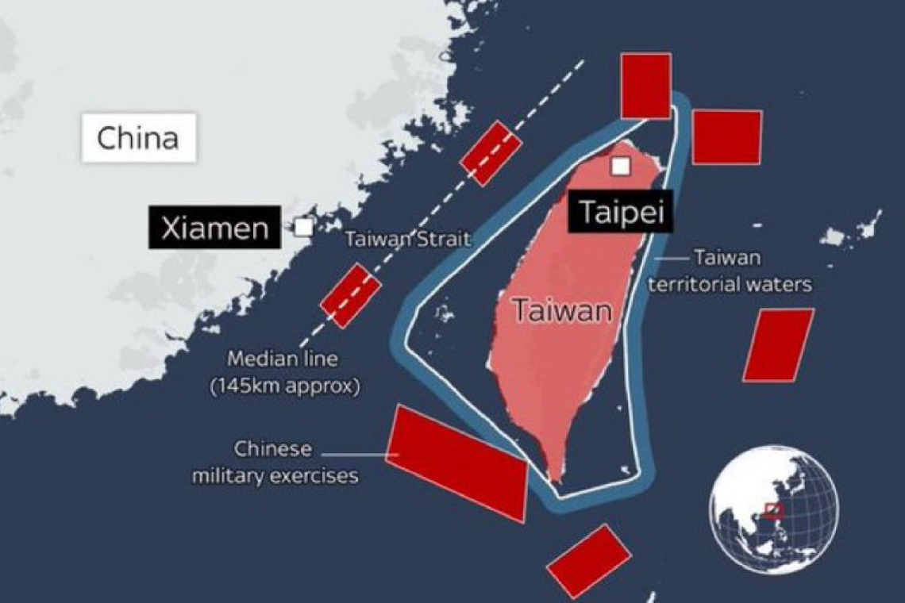

The 818th Separate Radio-Technical Unit at the Armavir Radar Station located in Krasnodar Krai, Russia is now knocked-out.  Here are images of the two gigantic radar buildings at that radar site (Click on image TWICE to fully enlarge):

May 24, 2024 “**NATO Just Took Out Russia’s Early Warning Radar Station**”

While this was not Russia’s only early warning system it was a prime one. This accelerates everything. Russia has to act against the attackers. It puts a “first strike” by Russia closer – closer to NATO, including the UK, and closer to the entire U.S. annihilation of so much Scripture, i.e. **Isaiah 13, 47, Jeremiah 50-51**, and New York City - **Revelation 18**.

**Below pictures: Normally, the entire Russia early-warning radar system provides the coverage seen in the graphic below**:

With the damage to the two radar stations at the Armavir Radar Station, there is now a GAPING HOLE in Russia's early-warning system against nuclear attack.

](https://halturnerradioshow.com/images/2024/05/24/Russia-Early-Warning-Radar-Attacked-1.jpg)The radar facilities bombed in Russia.

Yes, Russia has other early warning systems. Yet, this is a major attack, and Russia has made their statement that they will go after those that did this. They must protect their people and their nation. Their patience so far has been incredibly honorable – even when lives were taken because of U.S. and NATO attacks inside Russia.

However, it is obvious that neither the U.S. of NATO is going to slow down their sneaky attacks by proxies, or their direct attacks either. The show is over. Russia must proceed ahead to protect the nation.

Evil doesn’t care anymore who knows the truth – the lying public news takes care of over 90% of the shifting of blame to Russia for everything, but for those who know the truth and know the prophetic Word, it is obvious that end-time Babylon will be obliterated totally, as Jeremiah and several other prophets of the Bible prophesied.

You really should check out Thursday’s Steve Quayle’s interviews with Doug Hagmann’s program. Go to hagmannpi.com. The May 23rd broadcast title of Episode 4671 is: “USA Defaced, Replaced, and Soon Erased As Lucifer’s Lies We Have Embraced.” This is the last broadcast on May 23, 2024. It is just truth, facts, and no additions of opinions.

People in Canada can be imprisoned for quoting Bible verses and/or praying openly, for saying anything that upsets anyone else, for upholding the truth. It is fast coming as law in America and the world. Why? Because in order for the world ruler, the 1st “beast” of **Revelation 13**, is on earth, has been for a while, making his plans with the world’s leaders, and anxious to get on with ruling the world. In order for the globalists to feel safe to do all that for Mr. Beast, all Bibles must be destroyed. All who know the Bible must be martyred, all who speak in anyway against his takeover and the morality Lucifer desires for the world, will have to be eliminated.

Also, as I’ve said so many times, the DNA of most Christians in America, the UK, E.U. and NATO nations goes back to Abraham, Isaac, and Jacob, either to the House of Israel/Ephraim/Jacob, the ten northern tribes of Jacob, or the House of Judah – Judah, Levi, Benjamin. This lineage is the lineage from which Messiah came from – of the House of Judah. The U.S. is the #1 “holding tank” for these two houses biologically today, and most of them consider themselves “Christians” or “Messianics.”

Thus the U.S. has been slowly taken over, now quickly, by those that hate the Word, hate “Jesus” hate “God” – i.e. the spirits of fallen angels, Nephilim, and Lucifer himself. The U.S. is the #1 nation of child sacrifice to Lucifer, the #1 sex trafficking nation, drug-running nation, now becoming a cannibalistic nation. Thus Yahuwah is in judgment mode and the core of the habitation of Lucifer and fallen angels, western former Christian nations, 1) the U.S. 2) the UK 3) the EU and NATO nations, 4) Canada, 5) Australia and New Zealand.

Russia knows this. Yahuwah has raised them up to be as in the book of Jeremiah – Yahuwah raised up King Nebuchadnezzar of Babylon to judge. Today, the history and civilization of that mixture of the two Houses with Babel, founded by Nimrod, have merged once again as they did in 596 BCE. In 1992, Yahuwah spoke clearly to me as I read **Jeremiah 50-51**, “This is America.” He began showing me the massive portions of Scripture that IDed America, even NYC in **Revelation 18**. My pastor heard that from Abba Yahuwah and was excited that He has spoken that to me. As the years passed, more and more watchmen began saying the same thing.

Recently, Abba said to me: “Vladimir Putin in My Nebuchadnezzar” to judge America. Then I began hearing the main watchman with years of experience saying the same thing. I have been reporting on the coming of Messiah and the over 200 prophecies of the Bible about it, since the mid-1960s. I began teaching Revelation in 1970 in a small Bible school I helped found.

Abba called me as a watchman in 1985, with continual instructions. Today, what He has taught me aligns to all of the main Christian watchmen. **Isaiah 52** says that when the obedient-righteous watchmen of **Ezekiel 33** are in alignment, seeing “eye to eye” – then we will see the return of Yahshua Messiah. It is happening so completely now.

Yet, what is beautiful to those who love the Savior is hated with great hatred by all the damned, the world government that is now fast-forming. So many changes so quickly!

Now that all prophecies are happening at once, we see the rise of the plans of Lucifer. The provoking of WWIII by the U.S. and NATO is so obvious to those who know the Word and hear from Abba, and from just wise observer-seculars. It’s just obvious. Russian never wanted this. Iran never wanted this. Syria never wanted, or Lebanon, or anywhere else in the Middle, surely not Egypt. It breaks my heart because I lived in the Middle in Jordan and Israel 7 years each equally 14 years. It really began in 2005 with the removal of Israelis from Gaza. It grieved me so much because it was so evil. I was in Jordan at that time but visited Gaza via Christian Friends of Israeli Communities in Israel.

I know for sure the truth of what’s going on because I began watching it when living in the Middle East, and when I saw President Obama attack Syria for absolutely no reason that is valid – not one reason except to start the tearing apart of the Middle East for world government’s purposes. ISIS was created by the U.S. – as well as other terrorist organizations to do America’s evil. It has been a great grief seeing the moves of President George Bush and then George Bush Jr., put into office by the world government hierarchs of the time. The U.N. just got through admitting that Obama is in his 3rd term as President. He has been ruling, and back to ruling via his former VP who had Dementia back then and worse now. Obama said: “America is the greatest nation on earth; we will change all that.” He also said something similar that America is a Christian nation and “we will change all that.”

No elections by the people since JFK was assassinated. That’s a fact. All pre-planned 4-8 years ahead of time. 9/11 – done by the CIA and Israeli Mossad. Osama died of kidney failure not long after 9/11. He had zero to do with it.

The lies, the deceit, the underworking of Lucifer and fallen angels, and a nation addicted to TV propaganda, movie propaganda, and the steady lukewarm to cold attitudes of a dying “church system.” Today, few Christians know much of anything in the Bible, and most have rejected the Bible as a book of moral stories, not the Word of the Living God!

Many so-called Christians and Messianics have denied the Deity of Messiah, as He said would happen. However, He also said that those who deny Him, He will deny before His Father in heaven. (**Matthew 10** etc)

From the last Hagmann and Quale interview, May 23, 2024: Quayle: “If Biden signs the W.H.O. document that is coming out soon, then all of our rights will be turned over the United Nations. The U.S. armies are inside the U.S. now.”

Yes, we’ve been taken over – it began around 1945. But, since 2020 it has really taken off in detail. Operation Paperclip began around 1945-1947 bringing hundreds of chief NAZIs into the U.S. and put in key positions all over the nation, from the government, to science, to space exploration, to medicine, to psychiatry, to positions as college and university professors, and on and on – leading to the CIA, their lackey from the beginning, to introduce destroying drugs to youth, and implementing the horrors of Dr. Josef Mengele of fragmenting the minds of children and programming them to do atrocities. Mengele came into the U.S. many times to teach the CIA how to destroy American children and youth, thus destroy the nation.

I suggest a movie for truth’s sake: “The Boys From Brazil.” It is a fast-paced movie, with a lot of factual information in it as to what Mengele taught the CIA and brought into America. Yes, the CIA who learned from Mengele how to use LSD to control people and open their minds for the input of fallen angels and human lackeys.

I recommend that you listen to this interview of May 23rd of Hagmann and Quayle, and all subsequent interviews on Thursdays. You can get a list of daily updates of truth-news on stevequayle.com. You can subscribe to the broadcasts from that main page. You’ll get so much truthful news given to you so concisely that you just won’t hear from any public news sources. “The Canadian Prepper,” “The New York Prepper,” Brad at “Full Spectrum Survival,” - these are good reporters. Just news, but the real stuff.

With Quayle, the real reality-truth comes from the highest of sources of Intel, of top generals, of even “black ops”-the “above top secret” guys. I study everything out, but also when truth is told, Yahuwah lets me know in our spirit. Yahuwah is confirming to us in our re-born Spirit-filled spirit what is true, what is not, how to act on the truth, what to do, what not to do. Are you hearing Him? Are you studying the Word.

Quayle sends you to the Word. Pastor Faircloth in Georgia at Ignite Church is speaking truth under an anointing, as he even gives prophetic Rhema/spoken Word on Sunday mornings before his congregation, as well as the Logos/written Word.

It would bless you greatly in spirit, and in mind, to listen to Pastor Faircloth. Among all the false prophets and false pastors, he shines as a light to Elohim. The message Faircloth gave last Sunday was a mind-blowing study in **Ezekiel 33**. Abba wants to confirm things to you! Abba doesn’t leave us to man to tell us what to believe. He speaks directly to us through His Word, and through prophetic Word (Rhema). He wants to give instructions as to what to do, how to prepare, how to prepare others, what to believe. Isn’t that what Messiah said in **John 14-16**?

From Quayle and Hagmann from May 23rd: “The U.S. has shut down about 100 military instillations – and the UN troops have been using them…U.N. troops are awaiting their orders. Interesting that most U.N. troops are Chinese or Russian. They may be coming in across the southern border of the U.S. as well as others. They are all awaiting their orders to kill, steal, and destroy.

**Isaiah 13** is very explicit. **Jeremiah 50-51** is very explicit. Be sure you’ve listened to the podcasts of *Jeremiah*, especially the last few, dealing with these chapters under “Audio Teachings” –the tab is on the main page of comeenterthemikvah.com.

So, we’ve already been taken over. Another planned-demic is on the horizon, which means another “lockdown.” But this one will hold everyone in place, while we are destroyed by nukes, and by the ground soldiers of China, Russia, Iran, North Korea, drug cartels, and every terrorist group in the world just about.

There is more Hamas in the US than in Gaza for example. But, the US has so many terrorist groups of their own. Yet dulled people are lulled to sleep by TV, lying news, everything appearing to be all right, yet – so far from “alright” the truth is devastating. When will His people wake up – before many wake up in hell, or many lay dying on their way to heaven yet wondering “what happened?” All of Yahuwah’s children will go before the “judgment seat of Messiah,” before entering the Kingdom of heaven for placement, for rewards or not.

“**Wake up and strengthen that which remains and is about to die**” are Messiah words to the assembly of Sardis, not symbolizing U.S. churches – **Revelation 3**. It is also my calling personally from Abba – prepare My people for tabernacles.

Abba spoke to me in the early 1990s. I was teaching a Sunday evening class End-Time Prophecy at my church. I thought I had taught everything I knew. However, one night before taking communion at church I asked Him: “Now what do I teach them?” I was kneeling at the time. Abba answered my question with a booming voice, that’s Abba’s voice, saying: “Prepare My People for Tabernacles” – the 7th Festival of Leviticus 23 - the Wedding Feast after Messiah returns.

So many once-Bible-believing Christians are now listening to the false prophets, expecting great revival to come - churches filled with Christians and those seeking salvation. All teaching that Jesus won’t return for many years, depending on what false prophet a person listens to. Some say 50-100 years, some say 300 years.

The gates of entrance for the fallen angels are all open now. We are in **Genesis 6**, the “days of Noah,” “the days of Lot,” as Messiah told us. Yahuwah is in wrath mode, and it “begins with the household of God.” Yes, in every detail, and the 200+ prophecies, we are inside the days of Noah before the Flood. Are you obedient like Noah? Abba Yahuwah is calling His own people to prepare in all ways “to meet their God.”

From the May 23rd interview, Steve: “Fear is the spirit that has been released on earth.” It is a main spirit, a real spirit – a fallen angel spirit. Steve exhorts: “We go into battle singing praises to Yahuwah and Yahushua and the fallen ones cannot handle it. They flee.” Please read **II Chronicles 20** – going forth with praise defeats the enemy.

“An `exploit,” as in **Daniel 11:32** “is the supernatural power of God that allows a submitted one to do over and above anything the enemy can do. 100% submission to Elohim and obedience to what They say to do is mandatory. Int is a unity-war – we either unify with Elohim (Father and Son and Their Word) Father and Son unify us as in **John 17**. Then we are unstoppable, as the army of Gideon.

Yet, “fear has been released on the earth – a spirit of the fallen ones to scare everyone into doing what they’ve been told to do by globalist, governments in league with Lucifer and the Beast.” Added to that: Steve reported: “The new hurricane season is going to be the worst one in world history.” The weather is being manipulated as in “weather warfare.” Yet as Messiah said, the very elements of earth are going to be disturbed, so that our globe increases its problems with rotation and sustaining life (**Isaiah 24**).

This article is meant to instruct, but mostly to awaken those still asleep and doing nothing to prepare. Also, it is to strengthen those who are going against the pull of the global system of the Beast. These children of Yahuwah and Yahushua are getting stronger and stronger in faith and obedience to their soon-coming King of kings, and Master of masters (**Revelation 11:15-19**). I hope that’s you!

In the love of Yahuwah, Yedidah May 26, 2024 at 12:33 PM