APPALACHIAN HOMES DTROYED! NO FOOD! FEMA NO HELP!

ALERT! U.S. MILITARY CONFISCATING MASSIVE AMOUNTS OF FOOD

Millions of Appalachian Homes Impacted by Hurricane Helene Have No Flood Insurance Because Most FEMA Maps Don’t Consider Flooding From Rain

[by Ethan Huff | Natural News](https://www.naturalnews.com/2024-10-03-hurricane-helene-no-flood-insurance-fema-rain.html) October 4th, 2024 7:08 AM

**Most people are simply unaware that regular home insurance does not cover floods. Most people who live in a flood-risk area are unaware of their precarious situation, should a disaster strike.**

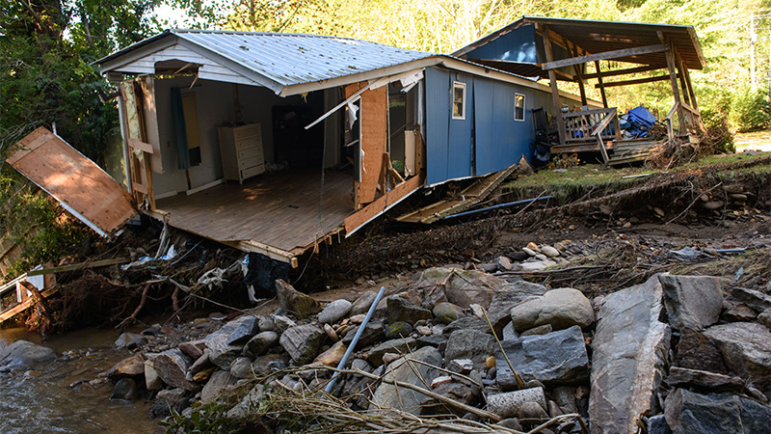

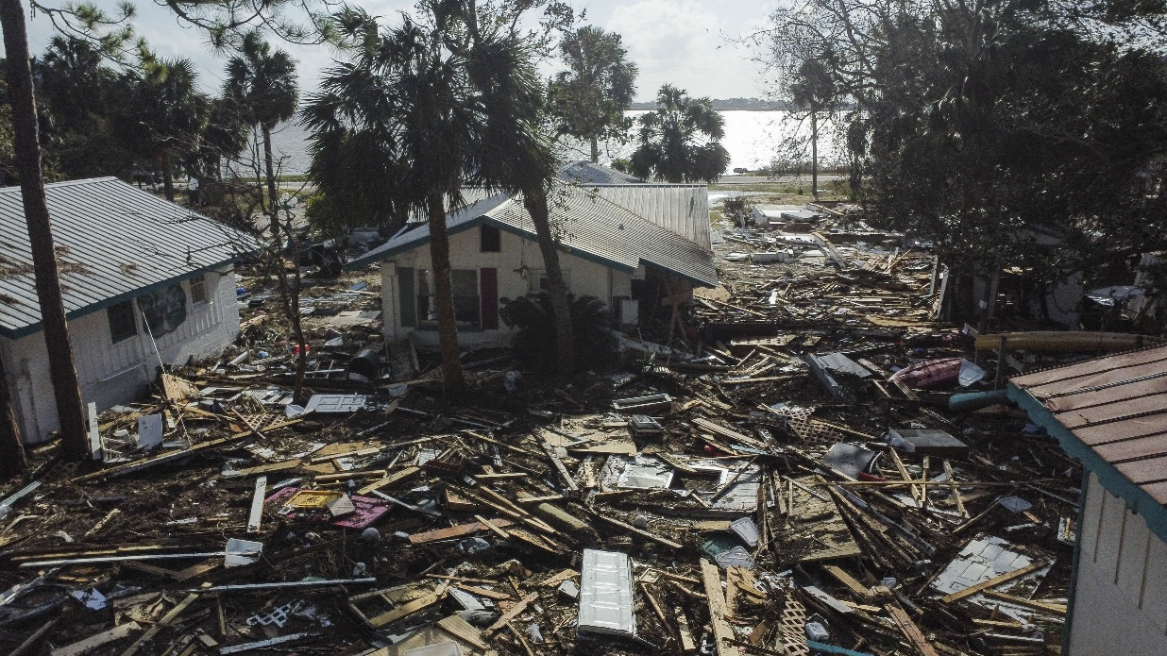

Image Credit: Melissa Sue Gerrits / Stringer / Getty

“The utter devastation caused by Hurricane Helene in the Deep South highlights a [very serious problem](https://finance.yahoo.com/news/helene-dumps-rain-millions-us-205413731.html) that now plagues many of the victims: a lack of flood insurance coverage. Of the upwards of $30 billion in physical damage and losses that Enki Research disaster modeler Chuck Watson estimates to have occurred from the storm, the vast majority will not be covered by insurance due to the way flood zones are mapped by FEMA. “The ratio of insured to uninsured has been dropping” all across the country, Watson warned. “And a lot of that is due to floods not being covered by the private sector.”

The Federal Emergency Management Agency says that just four percent of Americans have flood insurance. Most of these policies were issued under the government’s National Flood Insurance Program, meaning there are very few private-sector flood insurance policies.

There are two main reasons for this lack of coverage:

1) **Most people are simply unaware that regular home insurance does not cover floods.**

2) **Most people who live in a flood-risk area are unaware of their precarious situation, should a disaster strike**.

While homeowners who live within FEMA-designated flood zones are required by law to purchase flood insurance if they have a mortgage, only about one-third of America’s floodplains has been mapped by FEMA, according to the Association of State Floodplain Managers.

It turns out that most of the FEMA flood maps that do exist make no consideration for pluvial flooding, or flooding caused by rain. This is why most flood insurance policies are held by people who live along coastlines rather than inland.

For many, home insurance is just too costly. Home insurance in general is becoming too pricy and out of reach for many Americans, let alone add-on insurance for flooding of the kind caused by Hurricane Helene well inland from the coasts.”

*It is tragic, but many families whose homes were destroyed have no place to go to survive, no food, no help, and no money to pay for help. Of course they had no money for “flood insurance!” FEMA says they’re out of money to help people. Shelters! Is that the destination of the homeless? Much prayer needed! The FEMA camps are death-camps all over the U.S. – dividing families, having thousands of guillotines in each. Separation of men, women, and children – not good!

**FEW KNOW THE MEANING OF SERIOUS - A WAKE-UP ALERT**

**U.S. MILITARY CONFISCATING MASSIVE AMOUNTS OF FOOD**

The watchmen have been proclaiming and proclaiming the necessity of preparation. Few have done anything to prepare with food and water, let alone other things like back-up generators, back up medicines needed, back up ways of communication, and privacy shielding.

“SERIOUS ALERT CANNED FOODS ALL BEING CONFISCATED IMMEDIATELY BY US MILITARY - CAMPBELL'S CANS HUNDREDS OF FOOD ITEMS BESIDES SOUPS

OCTOBER 4, 2024

Here is what Steve Quayle received 10-3-24: “4 weeks ago in a town near me, a US Army `Multi Starred General’ went into a canning company called Campbell’s Soups. They checked out the whole place, including warehouses, and later told them they will buy everything they have, including what they have not started canning yet but will be taking everything they have there. These warehouses are huge and cover close to 400 acres of land.”

Steve: “YES, I JUST CHECKED WITH ONE OF MY FRIENDS WHO HAS A RELATIVE WHO WORKS IN MANAGEMENT THERE AND THE PERSON STATED THE FOLLOWING: **THAT THE "THE GENERAL WALKED IN" AND SLAPPED DOWN THE US GOVERNMENT ORDER REGARDING THE PICKUP OF ALL THE FOOD. AS OF 10:00 PM THURSDAY NIGHT, TRUCKERS ARE MOVING THE FOOD TO CLEAR IT ALL OUT AS FAST AS THE MILITARY CAN GET IT TRUCKED – PROBABLY TO SECRET UNDERGROUND GOV'T STORAGE LOCATIONS.**

I THEN ASKED MY SOURCE IF THE LARGEST FOOD WHOLESALERS HAD BEEN CONTACTED AND HE INFORMED ME THAT **COSTCO, SYSCO, AND MAJOR WAREHOUSE GROCERS** ARE BEING OR WOULD BE NOTIFIED ALSO.

BRETHREN, THIS IS THE PLANNED FOOD ATTACKS AGAINST THE AMERICAN CITIZENS; 'STARVATION NATION' - **LOOK WHAT PERSONAL PROPERTY RIGHTS NO LONGER EXIST IN NORTH CAROLINA** —THEN I ASKED HIM IF THE **RATION CARDS** ARE ALREADY PRINTED AND HE REPLIED AFFIRMATIVE BUT HE DIDN'T KNOW THE DATE OF IMPLEMENTATION – **BUT SOON AS THE GENERAL PUBLIC FINDS OUT EN MASSE** --- MORE AS I GET IT.”

Yedidah: This hurricane was geoengineered – no doubt about it – confirmed!!!

I have written much about geoengineering of weather. It began around 1947. Now, it is known that we have nearly NO natural weather patterns all over the world due to the manipulation and changing of it by the evil ones who have planned world government and world rule under a “bestial” system of no-rights for humans.

The massive food “re-calls” we’ve had in the last few years are 98%-100% bogus. It gives the government the right to take food and store in their underground bunkers to feed the big guys through a war they’ve planned and strongly encouraged.

What the government guys do not understand is that Russia’s bunker buster bombs carry 25-100 megatons of explosives, nuclear explosives. No one will live through nuclear war. Of course, many are taking off for South America nations.

We’re being set up folks! The watchmen are getting very tired and very frustrated from warning people who do not listen to the warnings. Apathy, lethargy, too-busy complex – whatever – the “nothing’s going to happen “bad” deception – we’re getting raptured deception. It’s going to cost a lot of people their lives.

Some things in life are just practical. Preparedness is one of them, even in peaceful times. But peace is being removed purposely and systematically from the whole earth now, so the sluggards need to get moving and prepare for no peace.

I appreciate those who keep us posted on reality, from sources that actually tell the truth!

TONIGHT – WE BEGIN HESHVAN. WE ARE “IN THE DAYS OF NOAH” as far as Yahuwah’s judgment reality, and as far as the actual month the ark sailed.

Yedidah – October 4, 2024