**THE ESSENES’ SOLAR CALENDAR – END OF THE AGE OF GRACE**

**Notes taken from *A Day At Qumran***

I was so shocked to hear Pastor Jamie Walden recently speaking of the Essenes of Qumran who had declared the year 2025 as the “end of the age of grace.” I’d never heard such a thing. He told how the Essenes used a solar calendar. I remember seeing the “sun dial” of the Essenes on display as I entered the Shrine of the Book in Jerusalem. It is a most wonderful place. It houses the scrolls found in the caves of Qumran, books of the Bible and writings of the Essenes, which were meticulously copied and preserved.

Somehow, I got Jamie’s information messed up, taking two different statements he made and coming up with 1+1-3. Please forgive me. I’ve got it right now! Only 1 day difference between the Essene solar calendar and the solar Gregorian calendar we go by! Now that is confirmed!

**So, yes, the solar calendar of the Essenes is 364 days to a year. The Gregorian calendar days are 365 to a year.** But… when did the Essenes begin counting the 364 days? Certainly NOT January 1st.

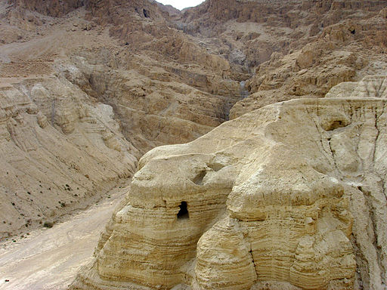 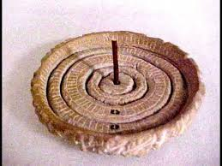

Left: Main caves of Qumran in which were found many scrolls.

Right: The sun dial

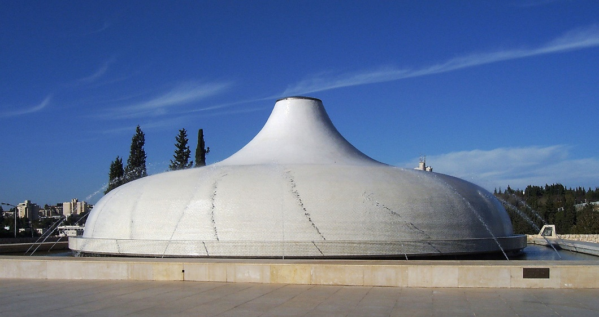

The picture above shows the outside of the Shrine of the Book in Jerusalem. It houses many of the scrolls found in Qumran. The main part of the Shrine is underground. But around its parameters some of the scrolls are on display in glass cases. Just seeing the first picture blow brings tears to my eyes. I was here many times and felt the presence of Yochanan/John the baptizer and the Spirit of Yahuwah still in those ancient books of the Bible that had been copied so meticulously by loving priests. They also copied the Book of *Enoch I.*

Every time I would go to the Shrine of the Book I would sit on one of the benches between the glass cases of the real scrolls on display. I would look up at the massive display with a scroll wrapped around it (picture below), the Isaiah scroll. Many of the scrolls are down below with the jars they were found in.

I felt like I was sitting among the most priceless physical objects on earth. I felt that way because they are – the Word preserved for us from their original language. I felt their pricelessness.

I love the Word of Yahuwah so much! It has been my life since at least 1963 when my life was changed forever. I found the Prophets words, and learned of Messiah all through the Tenach, especially in the Torah and Prophets. Once inside the Shrine of the Book, I did not want to leave. I still now in saying this feel the Presence of Yahuwah moving in my spirit.

The picture on left shows the Isaiah scroll (center) in the large casing on the platform, above the stairs. Right picture, some of the Isaiah scroll. It is the only scroll found so far that is totally intact – the whole book of Isaiah.

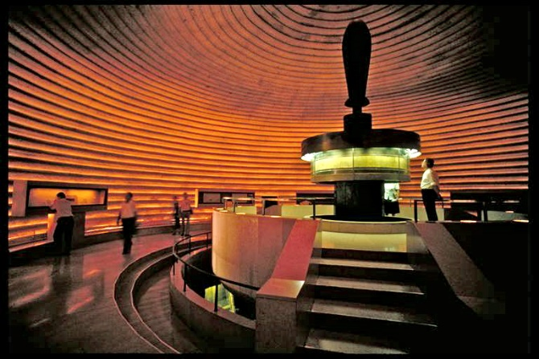 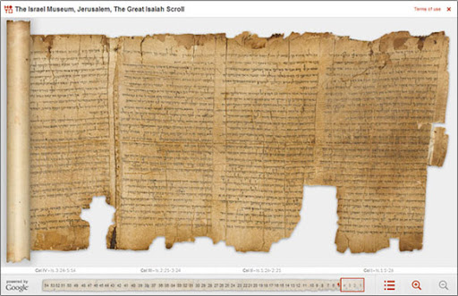

Last night, I got out all my books about Qumran, including a complete book of writings by the Zadok priests. That book is well worn, as I’ve studied it so much. These Torah guarders at Qumran prophesied our day in many ways - accurately. I was most intrigued by the prophetic writings of “The War Scroll” and its prophetic accuracy of things happening RIGHT NOW. The Essenes wrote much against the “sons of Belial,” exposing the false priesthood that is now international falsehood. The War Scroll is prophetic of NOW.

Standing on the watchman’s platform facing the Dead Sea, those hills across the Sea are in the nation of Jordan. I lived in Jordan 7 years and in north Israel 7 years. What Abba taught me those two places has helped me to see things very differently – getting out of a lying/deceiving culture into cultures that are ancient, is sure a lesson in itself. THE BIBLE IS NOT AN AMERICAN DOCUMENT. It is ancient, and teaches the ancient ways (**Jeremiah 6:16**)

The Essenes were not a bunch of religious fanatics with goofy ideas! They understood a lot that we need to understand. They were descendants of Zadok, the High Priest at the time of King David. I’m inspired to re-read the translation I have of the War Scroll. I bought these books, about 5 of them, at the Shrine of the Book.

**So, yes, the solar calendar of the Essenes is 364 days to a year. The Gregorian calendar days are 365. Now, we have that right (smile).**

The Essenes also used the ancient lunar calendar. How they came to the date for the end of Grace as 2025 CE, by the solar calendar, is still a mystery to me. But, accurate – Yes – I believe so!

We are “IN the days of Noah,” no doubt about it. All 200+ prophecies of the return of Messiah are now in play and increasing by the day! There was a day that Yahuwah told Noah to build an ark – a gigantic ship that would float on the top of worldwide flood waters. *Jasher* says that he and his sons built it in 5 years. *Jasher* is a book mentioned in two books of the Bible.

Yahuwah thoroughly trusted Noah, for Noah had the same righteous spirit as his great grandfather Enoch, and his grandfather Methuselah. Those Yahuwah trusts NOW are hearing His details and obeying His instructions! There is a remnant rising that KNOW Elohim and are strong in faith and obedience – who “tremble at His Word,” (**Isaiah 66:1-2**). These will do exploits at the time of the Beast’s reign on earth (**Daniel 11:32** and following).

Pastor Jamie Walden told how the Essenes accurately described the date of Messiah’s death and resurrection. The Essenes were Zadok Priests. They fled Jerusalem beginning when Hasmonean priests were put in power in Jerusalem by the Maccabees, after the forces of Antiochus Epiphanes were defeated.

How did these Zadok Priests get into using a solar calendar? Abba Yahuwah in His ancient paths for us to walk in has taught us much (**Jeremiah 6:16**). The Essenes also followed the ancient path of time-marking by the sighting of the new moon. But solar calendar? Yes, they used a solar calendar too, and it matches within one day of our 2024 CE Gregorian calendar as far as number of days goes.

Now I will give some quotes/information from a book I bought at Qumran on one of many visits there: *A Day At Qumran*. This is from the chapter on time-keeping.

Yes, it is nice to know that their solar calendar is 364 days. **However**, **when does it start, and when does it end?**

Going by what Yahuwah told Moses in **Exodus 12:1-2**, we see that He added a new calendar “for us.” He repeats “for us.”

The original calendar began with the creation of earth. It has been found in astronomy – the “Creation Week” began on a Sunday and ended on a Saturday/**Shabbat (Genesis 2:1-2**). Actually, it has been proved that creation of the earth began on a Tishre 1, the day of what became the Festival of Trumpets and shouting. Today, the Jewish rabbis and Israel still keep the Tishre calendar - Tishre 1 for the New Year. Thus “no man knows the day and the hour,” for the lunar calendar depends on sighting the new moon on the 29th day of the month, or by default accepting the 30th day as day 1 of the new month.

As students of the Word, we go by **Exodus 12:1-2**. With Moses, a second calendar was added – a calendar that put Aviv/Nissan as the first month, the Happy New Year month. Thus, Adar is the last month of the year, usually in March.

The month of Aviv became the “Happy New Year” month – Aviv 1.

Aviv, becoming the new 1st month, had to do also with the plague of hail: **Exodus 9:13-35.** The plague of hail destroyed the barley. The barley was in the Aviv stage – 2 weeks before harvest. Thus today, men like Brian Convery of avivofgod.com, go to the area of Jerusalem in March and check out the stage of the barley. The “aviv” stage is the stage of it being within 2 weeks of harvest. If the barley is not ready to be harvested in 2 weeks, an “Adar Bet” is declared – a second month of Adar.

The question is, with the Essenes’ solar calendar, where did they start from – ie when was day 1 of the 364 days of the year? Most likely they started from Tishre 1, just like Jews today do, and call Tishre 1 “Happy New Year.”

For us we do not go by the creation calendar for the festivals. We go by the Passover month as our first month, based on Yahuwah’s words to Moses in **Exodus 12:1-2.** Passover began the new calendar. Why? Because the Death, burial, and resurrection of Yahushua Messiah, represented by the Passover week of three Festivals: 1) Passover 2) Unleavened Bread, and 3) First Fruits. Messiah was the Passover Lamb, pure and undefiled. He went into the ground as a seed and then on First Fruits, He rose from the dead. 50 days later, as in **Acts 1-2**, He sent the Set-Apart Spirit of His Father on and into His disciples (taught ones) for their empowering and His reigning within them as He once reigned in Solomon’s Temple.

Did any of what He started of the 7 Festivals have an end? NO…

So, did the Essenes determine the end of grace from the new year beginning on Tishre 1, the creation New Year calendar, or the new year beginning on Aviv 1? I have yet to find the answer. But let’s look at that.

The days of the Essenes’ year is 1 day off from the Gregorian calendar. The Gregorian calendar is ridged – New Year always begins January 1st.

**Going by their solar calendar, the Essenes said that the “Age of Grace” will end as we enter 2025.** Is that to occur in September or October, or is that March or April? Is Happy New Year on Tishre 1 or is it on Aviv/Nissan 1?

If it is September/October on the Creation calendar going into 2025, it is ahead of the January 1st New Year. If their New Year is March or April/Aviv 1, it is later than the January 1st 2025. Either way, WHATEVER! 2025 is 2025!

The bottom line is that as we enter 2025 on some calendar, we are in a time of finalities. The end of the age of Laodicea, the striving of Messiah to get through to the heart of the lukewarm – that ended in 2001. I wrote 3 articles on that.

Yahuwah has stopped His pleading with the lukewarm to repent. Just as Esau waited too long to repent, as in **Hebrews 12**, though he “sought it with tears,” Yahuwah would not accept it. His time had run out!!! We all have a time that will run out, a time-frame to do as He has told us, and then judgment if we have not responded to His pleading. That is a very sober thing to go to Him about. If there is disobedience that continues – there is a cut-off point.

The Age of Grace, the time of “whosoever wills” is close to ending – where in September on the Tishre calendar, or March on the Aviv calendar. We are in a time-period now where we either line up to Yahuwah and Yahushua as Master, repent of all sin and stubbornness and rebellion, and press into obedience and walk the narrow path to eternal life, as in **Matthew 7:13-14** – or else, pay the penalty of a righteous good and set-apart Father.

Now, I conclude this article by giving you a few quotes from **A Day at Qumran, The Dead Sea Sect and Its Scrolls, compiled by The Israel Museum, Jerusalem, edited by Adolfo Roitman, pages 19-22. (Half the book is in English, half in Hebrew)**. I choose to give you English (smile).

“Absolute adherence to the prescription for the true calendar was regarded by the Qumran sectarians as a religious duty of the highest order…The issue was central to the sect’s consciousness and several scholars believe that the controversy that arose when the priestly establishment adopted the Seleucid solar-lunar calendar during the reign of Antiochus Epiphanes in 167 BCE. (see **Daniel 7:25**, **II Maccabees 6:7**) was probably one of the decisive factors in the Qumran groups departure from Jerusalem some years later, during the reign of the Hasmonean king Jonathan (150 BCE)

“A different calendar based on the sun is mentioned and even described in detail in some scrolls …These sources indicate that the Qumran sectarians had a solar calendar with a 364-day year. It was divided into twelve equal months of thirty-days, and at the end of each quarter (the third, the sixth, the ninth, and the twelfth month, an extra day was added, giving these months thirty-one days.

In this system, the New Year (Rosh ha Shanah), as well as the first day of every season, always fell on the same day of the week. Passover always fell on Wednesday.” [My note: This is fascinating in that Messiah indeed died on a Wednesday and was put into the grave before sunset which began Passover]

Shavu’ot always fell on a Sunday [This is by Yahuwah’s Hebrew calendar], Yom Kippur always fell on a Friday.”

“Actually, it was not the Qumran community that established the solar calendar; this calendar was the product of an earlier Jewish tradition, which is reflected in pre-sectarian sources that were also found among the Dead Sea Scrolls, such as the Book of Enoch, the Book of Jubilees, and the Temple Scroll.

One of the practical results of accepting the solar calendar was that the Qumran sectarians did not observe the Festivals on the same day as the bulk of the Jewish people, thereby cutting themselves off from the general community and establishing their own way of life.

The scrolls at Qumran contained evidence of a lunar calendar of 354 days with months alternating between twenty-nine and thirty days. The question of whether the members accepted the lunar calendar in addition to the solar calendar or whether the lunar calendar in fact belonged to other groups is still to be resolved, though it seems that the members of the Qumran community used the two calendars simultaneously and they developed ways of harmonizing one with the other.”

“Did they have certain equipment for that purpose? It was discovered that the stone disc (picture above) discovered in the 1950s was actually a unique type of sundial. It is possible that the Qumran calendar was calculated using the sundial, and that the hours of the day and night were directed in accordance with the season.”

The Essenes were a great blessing to us - that continues on to this very day. The heart of those men was to copy the Word of God, including bring alive to us the Book of Enoch. There are so many things we wish we knew better. However, we see Zechariah and Elizabeth (Elisheva) took their baby boy to the Essenes to raise there. Zechariah was a Zadok-lineage priest in Jerusalem. He was later killed by other “priests” by what Messiah called “viper seed,” hybrids from the time of Ezra.

We just know that now, we are in a time period of transition of the whole world system – the time of “globalism” - a time when the two witnesses of **Revelation 11** are on the earth preparing, a time when the Beast is on the earth preparing, and those rabbis of hybrid blood still, preparing for his enthronement as their messiah as a redeemed Nachash, the serpent of the Garden (**Genesis 3**).

We are at a time of tremendous apostasy by the former Christian churches of America, the UK, the EU. We are at a time when the judgment of Yahuwah is dividing His sheep from the pretending “goats.” Yahuwah is rising in His wrath. We are in the time when martyrdom of Christians in the hundreds of millions will take place – the guillotines by the tens of thousands are in FEMA camps all over the U.S. This is the time when the Luciferic Talmudic laws of “Noahide” creation will be used to behead His people according to the words of the Talmud, which supersedes the Torah in rabbinic Judaism.

What the Essenes gave us is priceless. So, whether solar calendar, or lunar calendar, or both, they guarded the Torah. We guard the ancient paths of the Torah and worship and adore the Son of Yahuwah who died for us and rose again to give us eternal life. They gave their lives to copying Scripture – HalleluYah!

Let us take this information to impress upon ourselves the shortness of the “hour.” Lucifer knows (**Revelation 12**) that his time is short and shortening. It is time for him to make his moves to destroy all of mankind. Everything for that is being set up. Yahuwah is removing His restraints. Abba Yahuwah sees beyond the “short time” for the return of His Son and the resurrection of His chosen people – their bodies coming to life and joining their spirit-bodies coming down from heaven. It’s all in the Word in detail. HalleluYah!

In His love, Yedidah – July 19, 2024